Academic Technology ISIT Update

3-4-24

LTI Requests - Proposed Draft Language

Faculty – If you anticipate using a LTI, or Learning Tool Interoperability, in your Canvas shell in an upcoming semester, you must submit a request to have the LTI reviewed and approved at least one semester before the semester you intend on using the LTI. Once the Academic Technology department receives the request, the vendor supplying the LTI will need to agree to our district’s LTI contract which outlines the vendor’s compliance with data privacy and accessibility requirements. Upon receiving representative signatures from the vendor and from the district, the contract will then need board approval.

Here are some examples of LTIs that have been approved with signed contracts and currently being used by BC faculty :
- Cengage
- McGraw Hill
- Pearson MyLab
- NetTutor
- Turnitin
Here are some examples of potential LTIs that could be used within Canvas:
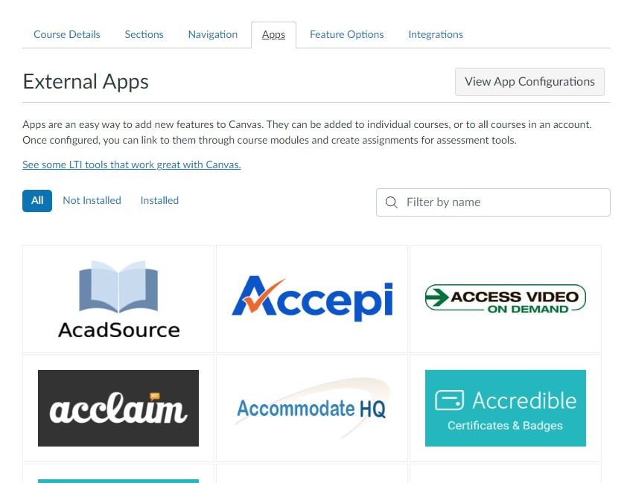

Canvas Request Support Form Change
- The current Canvas Request Support form focuses solely on faculty requests regarding Canvas. We are looking to broaden the use of this form to include all types of requests that faculty might need from Academic Technology.
- 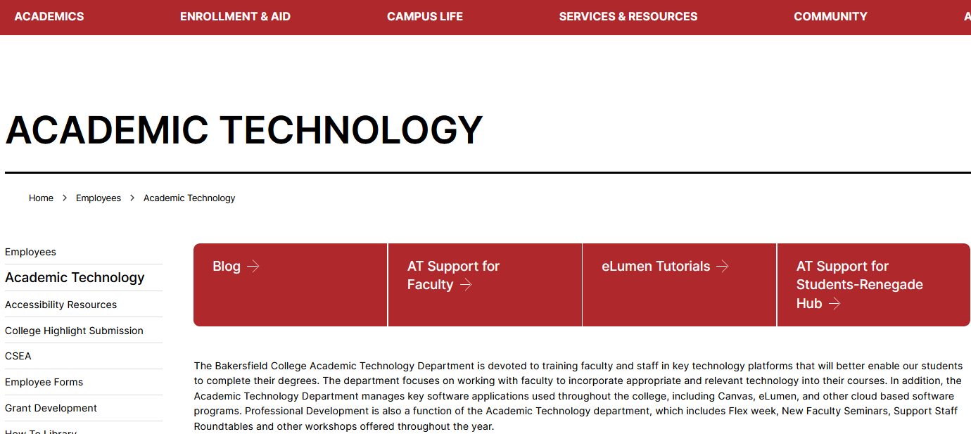

Pronto Demo
- There will be a demo of Pronto on Thursday, March 7, at 9:00am. If you can make it, please join us at https://pronto.zoom.us/j/8486956804

Turnitin AI Detection
- The Turnitin AI detection service has been purchased and is now available for use.

eLumen Dataload Issues
- We are working with our district office IT to resolve formatting issues with our data load files from Cognos.
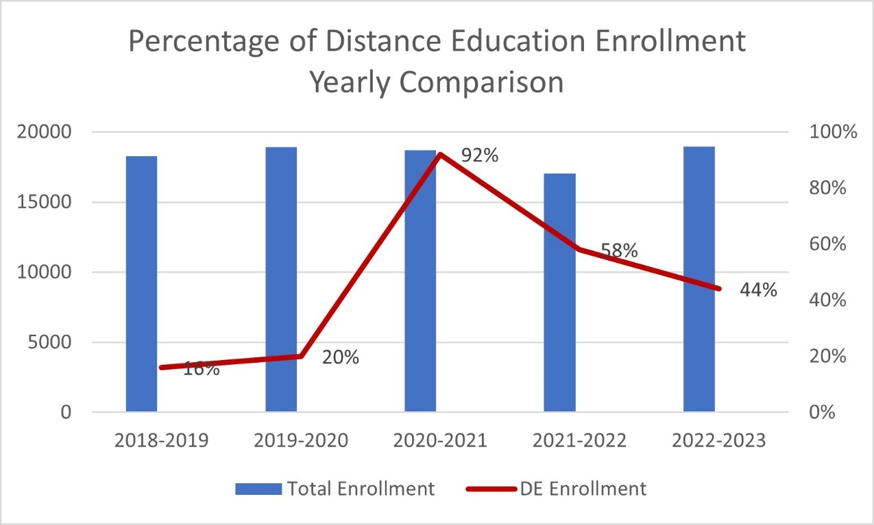
*Fall 2023 enrollment data from Data Mart shows that 33% of our enrollment came from distance education classes.

