2024-27
Technology Support Services
Bakersfield College
Kern Community College District
Bakersfield College Technology Plan
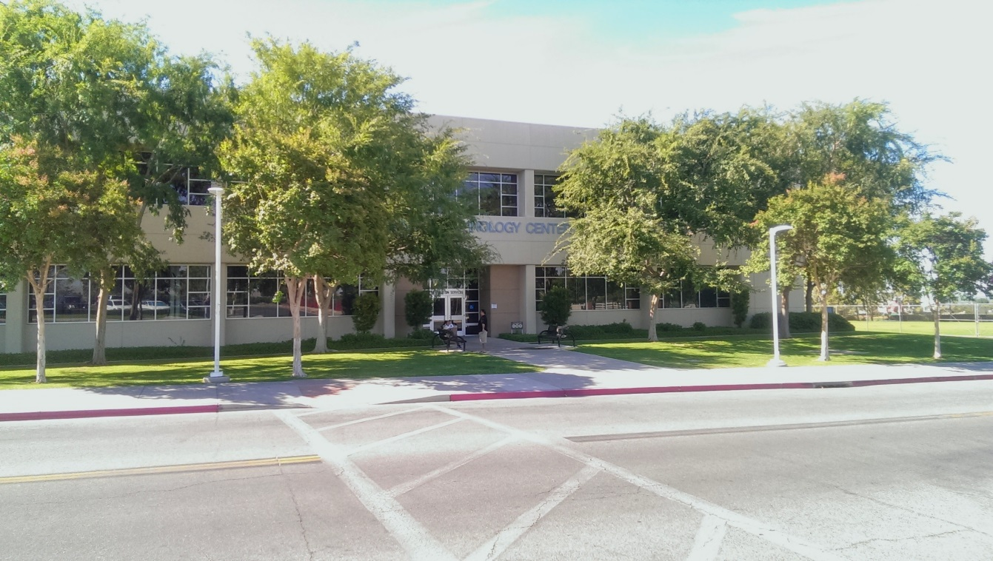

Contents
Technology Services 2
Mission Statement 2
General 2
Staffing 2
Academic Technology
Student Success Technology
Review of 2020-2023 Technology Plan Initiatives 6
Strategic Objectives 7
1. Support Student Success with Technology 7
2. Support Instruction and Learning through technology 7
3. Employee Professional Development 8
4. Develop sustainable technology funding strategies 8
5. Enhance end-user education on security 8
6. Improve Campus Processes 8
7. Infrastructure Improvements 8
8. Provide Exceptional Customer Service 8
2024-2027 Strategic Initiatives Table 8
Appendix A: Governance and Committees 11
Technology Committee (ISIT) 11
District-wide IT Directors Committee 11
Facilities Committee 12
Program Review Committee 12
Accreditation and Institutional Quality Committee 12
Professional Development Committee 13
Strategic Directions Committee 13
Accessibility Task Force 13

Technology Plan 2024-2027

Overview

Mission Statement
Technology Support Services coordinates, develops, designs, integrates, maintains and supports the technological environment that allows students, faculty and staff to carry out the mission of the college and community needs with great efficiency and flexibility.

General
The Bakersfield College Educational Master Plan has several components that have technology implications. One of the first areas is a goal to scale the Bachelors of Science degree by way of the Early College Program and the Inmate Scholars program. Introducing technology into the prisons is challenging but one that is critical in order for those students to get the hands-on experience they need for the industrial automation degree.
Another focus is the continued development and use of the Program Pathways Mapper tool. Bakersfield College has earned awards for the development of this tool. Looking ahead, Bakersfield College will utilize the resources and visibility earned through initial innovation to expand its curricular alignment and mapping work to the full CSU system and begin deepening alignment with the University of California (UC) Transfer Pathways. In particular, STEM pathways to UC baccalaureate completion will be of primary focus.
Bakersfield College has new academic scheduling software called Ad-Astra. This replaces the previous in-house developed tool which was obsolete and ran on antiquated code and hardware systems. Ad-Astra is a project that has district-wide implications and has improved the agility and flexibility of the colleges to schedule classes appropriately and efficiently. We have been using this software since Spring semester 2023.
Finally, in addition to the technology plan being aligned with the Educational Master Plan, it is also aligned with the Vision for Student Success goals and the college Strategic Directions.

Staffing
The staff of the Technology Support Services Department is made up of one Director, one assistant director, eight Systems Support Specialists I’s, two Systems Support Specialist II’s, one Information Services Coordinator, and Department Assistant. The staff provides support for the Bakersfield College, Southwest, Delano, Weill and Arvin campuses. With over 7500 total computers and a plethora of other network attached devices, this department works diligently to keep things running. We have doubled the amount of computers we support within the past three years since COVID work from home. Media Services has been folded into Technology Support Systems facilitating the implementation of all media related-equipment requests including setup, video production, interactive instructional and administrative videoconferencing, and video streaming. Staff covers all non-computer related multimedia equipment at the main campus, the Weill Institute, Bakersfield College Southwest, Arvin and the Delano Center. The department is constantly looking for opportunities to improve efficiency, reduce waste, and improve processes to make the technology experience better for the Bakersfield College students, staff, and faculty.
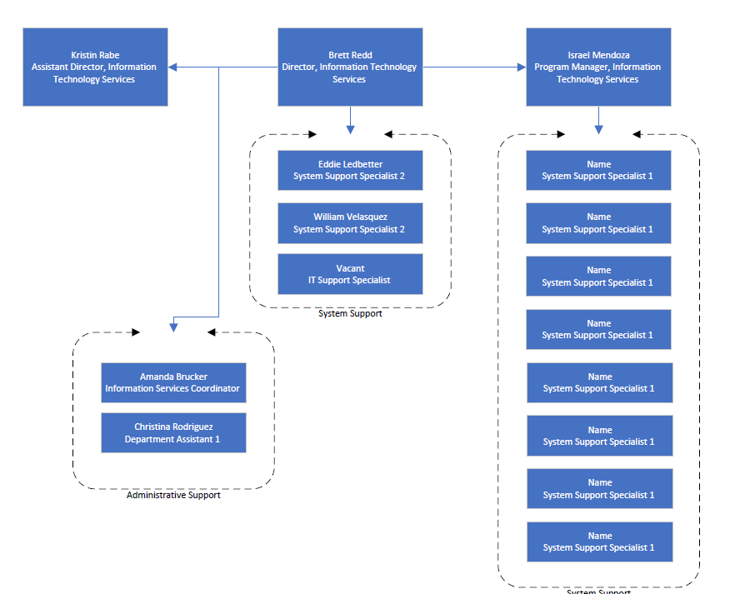
Bakersfield College has over 4000 computers in specialized computer labs and remote carts supporting student learning outcomes in the areas of math, tutoring services, computer graphics, multimedia, drafting, business, and health sciences. All disciplines have access to mobile laptop carts as part of the Hyflex project. These computer labs, remote carts, and classrooms are spread across multiple sites including the main campus, Delano, BC Southwest, Olive Drive Training Center, Shafter, Arvin, and the Adult School.
Bakersfield College recognizes the importance of keeping its computer labs equipped with as up-to-date equipment and software as is fiscally possible. A three- to five-year replacement cycle has been unofficially agreed upon and has been followed as closely as budget will allow. Office computers, with the exception of some used by high-end users, have historically gone longer than three years before replacement. Each department is responsible for reviewing its own needs for upgrading and then utilizing a formal procedure for requesting replacement equipment. The Technology Support Services department in conjunction with the ISIT Committee has established and publishes a minimum configuration for all desktops.
Technology Support Services actively participates in district-wide committees and decisions relating to technology. The Director and Assistant Director of Information Technology, are a member of the IT Directors committee and play two roles on the committee. The first role is as an advocate for the needs of Bakersfield College, communicating needs and priorities. The second role is to help solve district-wide technology problems and to set standards and provide recommendations for how technology is used within the Kern Community College District. The Director, Information Technology, also serves on the President’s Cabinet, Admin Council, Information Systems and Instructional Technology Committee, and the Accessibility Taskforce. The Assistant Director, Information Technology serves on the Accreditation and Institutional Quality Committee, as the Program Review Committee Co-chair, Information Services and Information Technology Committee and the Facilities and Sustainability Committee.
Our Information Services Coordinator participates in the Information Services and Instructional Technology committee. In addition, information is shared within the IT Director’s committee relating to district office systems and software upgrades. Those updates are then communicated to the campus via the ISIT committee or, in some cases, campus-wide communications. More information about IT Staff involvement on campus committees can be found in the Governance and Committees section of this document.
We are consistently looking to best utilize resources and create various replacement policies, which have been suggested to help support technology in the most effective way. Bakersfield College has media equipment stationed in most classrooms on campus and at remote sites and also offers equipment for faculty and staff checkout. If equipment is stolen, we replace with repurposed equipment. We do not replace equipment such as projectors with brand new units unless funding becomes available. A project is created for the ISIT unit plan and it’s added to our request for replacement equipment.
Bakersfield College Technology Support Services has moved away from video production and live streaming and has engaged with the Marketing team to provide technical support to the video production services. The college has moved away from in-house production.
We support district-wide videoconferencing efforts, both instructional and administrative. We serve as technical support and develop and implement policies and procedures for instructional and administrative videoconferences.
Bakersfield College Early College Initiative successfully piloted an interactive class with North High School during the Spring 2019 semester. The class was successful and further growth is expected for this type of technology within the Kern High School District. Previously, interactive courses were only taught between Bakersfield College and our Delano campus of Bakersfield College through the R.I.D.E. (Rural Initiatives Distance Education) program. In early 2017, videoconferencing equipment deployed at three Delano area high schools (Delano Unified High School District) and Arvin High School (Kern High School District) continues to assist the Dual Enrollment/Early College Initiative with Bakersfield College. This initiative will allow students currently enrolled in high school to participate in college level coursework without leaving their campuses. The courses will be taught from the Delano campus of Bakersfield College covering multiple subjects.
All multimedia equipment used on campus such as projectors, document cameras, and other technology are selected by our staff based on the flexibility and reliability of the equipment and the needs of the requesting campus departments.

Review of 2020-2023 Technology Plan Initiatives

The following initiatives and results are from the most recent technology plan (2020-2023). The results column provides and update on previously set initiatives.
Initiative | Result
Expand and improve the wireless access on the Bakersfield College campus with a goal of complete wireless coverage. Measure J money will be used to fund this initiative.  (Strategic Objective 1, 2, 7) | The wireless projects have been completed in early 2023 – we are seeking funding for additional outdoor spaces. Internal spaces are at 99% and external spaces are at 50% coverage.
Review and maintain current infrastructure and classroom technology by supporting requests made to the Instructional Technology Committee. Prioritize and determine best use of department and college funding to update and maintain technology.  (Strategic Objective 1, 2, 7) | We continue to do this and move forward with updating classrooms as funding becomes available.
Develop a video streaming framework that will encompass live event capture, editing, and digital archiving of materials. This infrastructure will be accessible to the campus community for on-demand training and materials. Review of budget, equipment, and facility needs as required.  (Strategic Objective 2,4,) | We found this to be not feasible to complete. Zoom and Canvas and YouTube worked best.
Work collaboratively with the facilities team and Facilities Committee on the new Measure J construction projects.  (Strategic Objective 1, 2, 7) | Continues today
Continue to improve Program Review Process by looking at online forms for resource requests  (Strategic Objective 1, 6) | Continues today
Implement a document imaging solution to support Admissions and Records, Financial Aid, and Presidents Office.  (Strategic Objective 1, 6) | Completed through Captiva in 2023
Develop a comprehensive online student onboarding process that ensures successful engagement with courses at the beginning of the semester. (Strategic Objective 1, 2, 6)  [Academic Technology] | We have not yet developed this
Create the infrastructure and processes to make academic badging an integrated part of curriculum, assessment, and student communication. (Strategic Objective 1, 2, 6) [Academic Technology] | Academic Technology has been working on this.
Develop and launch an education pathway and certification process for online faculty. (Strategic Objective 1, 2, 3, 6) [Academic Technology] | Academic Technology has not yet completed this
Develop and implement an enhanced scheduling process using predictive analytics and data-driven methodologies to support maximum student completion. (Strategic Objective 1, 2, 6) [Academic Technology]

Strategic Objectives
The purpose of the Strategic Objectives section of this document is to give a brief overview of the technology focus in each of the listed areas. In the next section are specific strategic initiatives that will fall under one or more of the strategic objectives listed in this section.

Support Student Success with Technology
Use technology to provide and enhance student support services enabling greater student access and success.

Support Instruction and Learning through Technology
Provide leadership and support for effective, high-quality instruction, and learning outcomes through the appropriate use of technology, including making content accessible.

Employee Professional Development
Provide technology-related professional development opportunities to IT staff to improve technology skillsets. Provide technology related training to end-users to improve technical literacy.

Develop sustainable technology funding Strategies.
Develop funding strategies in order to sustain and enhance mission-critical technologies in times of economic scarcity. Continue to evaluate and develop processes for fair and timely technology allocation. Evaluate Total Cost of Ownership.

Enhance end-user education on Security.
Proactively provide end-user education to reduce the risk of social engineering and to increase general technology security competence.

Improve Campus Processes
Look for opportunities to improve campus processes by better utilizing existing technology tools.

Infrastructure Improvements
Continue to evaluate opportunities to improve campus infrastructure either as part of new construction or smaller individual projects.

Provide Exceptional Customer Service
Enhance responsiveness to end-users. Utilize the ticketing system to track, analyze, and report. Develop improved process for timely and relevant communication to all campus constituents related to planning, improving, implementing, upgrading, or removing campus technology.

2024-2027 Technology Initiatives:
Initiative | Result
Expand and improve the outdoor wireless access on the Bakersfield College campus with a goal of complete wireless coverage. Measure J money will be used to fund this initiative, and other funding initiatives.
(Strategic Objective 1, 2, 7)

Review and maintain current infrastructure and classroom technology by supporting requests made to the Instructional Technology Committee. Prioritize and determine best use of department and college funding to update and maintain technology. (Continues from previous plan)
(Strategic Objective 1, 2, 7)

Review staffing levels for current infrastructure
(Strategic Objective 1, 2, 6)
Work collaboratively with the facilities team and college safety team to provide early notification systems with telephone and hardware.
(Strategic Objective 1, 2, 7)

Continue to improve Program Review Process by looking at online forms for resource requests
(Strategic Objective 1, 6)

Implement new Accessibility Guidelines during procurement of hardware and software. Accessibility Committee Maturity Module for reference.
(Strategic Objective 1, 6)

Develop a comprehensive online student onboarding process that ensures successful engagement with courses at the beginning of the semester. (Strategic Objective 1, 2, 6)
[Academic Technology]
Develop and launch an education pathway and certification process for online faculty. (Strategic Objective 1, 2, 3, 6) [Academic Technology]
Develop and implement an enhanced scheduling process using predictive analytics and data-driven methodologies to support maximum student completion. (Strategic Objective 1, 2, 6) [Academic Technology]

Academic Technology
Mission:
The mission of the Academic Technology department is to increase the instructional effectiveness of the college through better technology use and training. The Academic Technology department uses the expertise of our team to help faculty to build engaging courses and find and develop materials that will aid in student learning and remove barriers to learning. The department is focused on breaking down equity barriers by making more courses available online, helping students to be more prepared to take those courses, and helping faculty provide low or no-cost materials for their courses, where applicable. With fewer barriers to entry, students are more likely to persist and complete their degrees which is how our mission ties into the college mission.
As BC has transitioned to online learning, the Academic Technology Department has been integral to the process of bringing courses online. The department has offered workshops on all aspects of technology, both in-person and online to make both faculty and staff more comfortable with the technology being used to educate and inform our students. In addition, the department has worked one on one with faculty and staff to bridge technology gaps. The department has led the way in ensuring that diversity, equity, and inclusion are a focus in our interactions with students and staff alike. There is an additional focus on humanizing our courses to encourage students who might otherwise struggle in both online and face to face courses.
About:
The Academic Technology team supports faculty and staff on campus. The team consists of 2 faculty members, a program manager, educational media design specialist, executive secretary and director. In addition to the information above, the team supports the e-catalog, the faculty evaluation process, the assessment process and is a huge contributor to professional development on campus.

Org Chart:
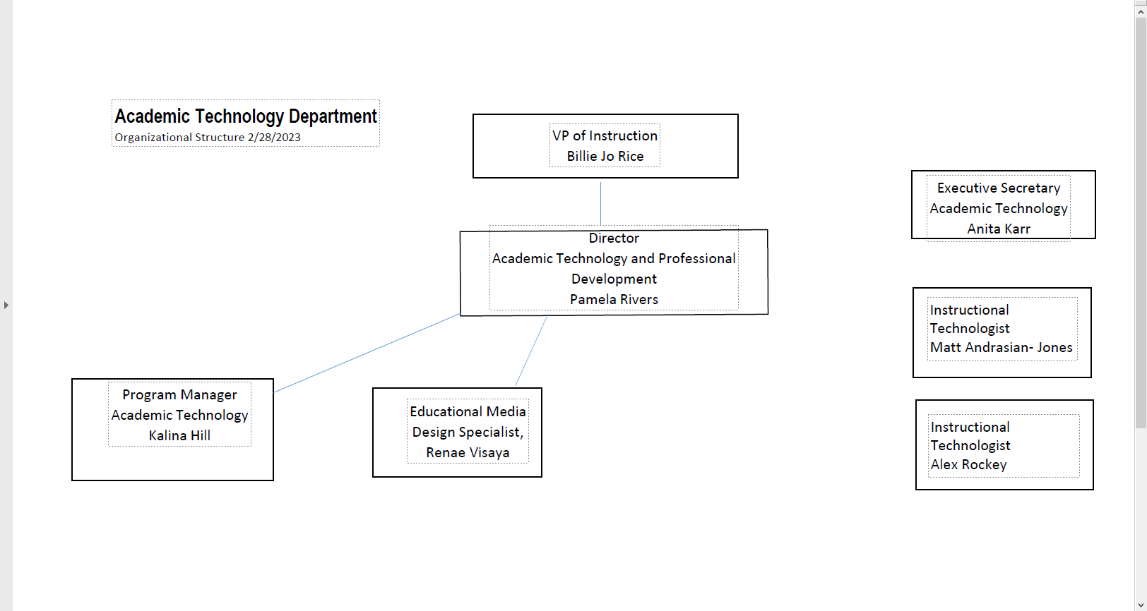
Goals for 2023:
Goal 2: Hyflex
Strategic Direction: 1, 2, 3, and 4
Action Plan: The team working on hyflex has identified three phases to implement NUMBER OF hyflex classrooms across the Bakersfield College campus. Phase 1 will be to design and build hyflex classrooms. The team will identify funding opportunities and receive approval for funding for hyflex classrooms. The team will also research hyflex models at other institutions to inform the design of hyflex classrooms.
Phase II will focus on building campus interest and support. The team will highlight the availability of hyflex classrooms via existing communication platforms and presentations to committees and departments.
Phase III will focus on providing faculty high-quality professional development opportunities on hyflex course design and teaching strategies.
Status:
OER- continued expansion of the OER program to become systemic
Strategic Direction 1, 2, 4
Action Plan: The team working on OER has a multipronged action plan. Last year saw a great increase in the number of courses with some OER and the number of sections being offered overall. We increased the number of total sections by over 100 new sections. Our goals this year are to focus on more systemic change with the addition of the Chancellor's office ZTC grant. This work will come in 3 phases.
Stage 1 is the planning phase. During this phase, Bakersfield College has assembled a small team to work on creating a pathway through the general education breadth for students who would like to take all general education with no textbook costs. This team has identified the gaps where there are no OER options available and will work with faculty strategically to fill those gaps and create options for students for general ed. During this phase, there will also be an emphasis on making changes systemic. A librarian is a part of this team as a means to include the library in the OER process, allowing faculty to work with the library to identify OER materials and to find the best way to house the materials that are created/ discovered. This team will also identify long-term need including staff, funding, and other resources to ensure an ongoing focus on OER materials, matching the mandate from the Chancellor's office.
In Phase II of this program, the focus will be on programs. Programs that have a strong desire to work with OER materials or who have already begun the OER work for a specific class will be asked to partner with the team to continue the process of making all classes within a program OER. At this point, the team will expand to include more faculty from different disciplines, preferably faculty from the programs being targeted for OER.
Phase III: This phase will involve an expansion to more programs, possibly as many as four with an emphasis on those programs that have multiple faculty who are willing to work on the OER program. This phase will be implemented by the Fall of 2024 and by this point, the team would like to have a full time librarian devoted to working with OER.
Status: The college has received the funding for Phase I and has begin partnering with faculty to created courses that with have the ZTC symbol next to them. The application for Phase II has not come out yet, but programs have been identified.
POCR
Strategic Direction 1, 2, 4
Action Plan: The Academic Technology Department has identified three phases in order to conduct Peer Online Course Reviews (POCR). The first phase focuses on training a team of faculty. As such a number of faculty were recruited and enrolled in the @ONE POCR Training. As a subset of phase one, these faculty will receive training to norm their practices and conduct course reviews against the OEI Course Design Rubric throughout a series of workshops. During the second phase of the process, courses from the Person-Up Fellowship will be identified as courses to review. The POCR team will work through a tier-structured review model in order to review, edit, and verify courses through the review process. During the third phase, the finalized review courses will be provided to the CVC-OEI for final review, before being input into the OEI Course Exchange.
Status: A team of faculty has been selected and received training from @ONE. The POCR Team, as the faculty have come to be called, are currently going through a series of 4 workshops which will enhance their morning practice.
Faculty Workshops/ Resources/ Learning
Strategic Direction 1, 2, 4
Action Plan: The Academic Technology Department has a repertoire of 25+ workshops, a variety of resources for learning . Out of these workshops, those that were identified by campus employees in a Workshop Needs Assessment Survey will be given priority for implementation. Other workshops that will be given priority are those that align with campus-based initiatives such as Hyflex as well as those which correspond within the semester needs of faculty. Additionally, a badging incentive model will be reviewed and edited to encourage workshop attendance by the campus community. Faculty in Academic Technology will continue to develop and deliver an instructional video blog, Pedagogy in Practices, that marries technology and pedagogy. Accessibility will be worked into each workshop offered, in order to teach individuals how to create accessible content and provide proper accommodations. Another point of action, is that the workshop structure will be reviewed and expanded to include further training for classified members of the campus community.
Status: Workshops are being offered on a near weekly basis. New workshops are currently being developed.

CLEAR
Strategic Direction: 1 and 4
Action Plan: Learning science has given us a strong foundation upon which we can create classrooms that best support student learning, satisfaction, and retention. However, translating the evidence-based practices into the classroom requires reimagined professional development (Burdman et al., 2021). The Center for Learning and Applied Research (CLEAR) action research fellowship will help function as a bridge for faculty as they seek to make clear how existing research on learning can be translated into their course. By supporting faculty-led action research, the CLEAR fellowship will facilitate meaningful professional development opportunities with transformative potential for how faculty teach across Bakersfield College. This faculty-led action research project will not only transform how faculty teach within their courses, but faculty who have conducted their own action research projects will disseminate research in their departments and across the district to scale transformation across the district.
The team will manage this research project by first opening a call for faculty to apply for the fellowship. Then the leaders of the project will design 10 workshops to take over the 22-23 school year to guide faculty in designing and implementing their own action research project. The leaders will pull in appropriate campus experts to lead workshops on finding literature and ethical research. The fellowship will culminate in a virtual poster session in which fellows share the results of their work.
Status:
The team has identified funding for the fellowship and has identified thirteen fellows. Fellows have attended 3 of the 10 workshops and have identified their research questions.
In Summary:
The Academic Technology Team’s goals closely align with the direction of the college, including the focus on persistence and student success. The AT team is determined to make learning accessible for all students by reducing barriers to equity and meeting the needs of faculty.

Student Success Technology:
The mission of the Student Success Technology (SST) department is to facilitate the use of technology resources that support the efficiency and the effectiveness of Student Services in order that non-academic obstacles will be minimized, allowing all students to attain their educational and career goals more easily (Strategic Direction #2: Student Progressions & Completion).
The SST assists the Student Services departments by researching and evaluating appropriate technology solutions and by providing training, documentation, and ongoing support of adopted technology resources.
Products and services that are expected to be reviewed and considered for future adoption include:
- Client Relationship Management system (CRM)
- Ticketing system to track student requests for A&R services
- Predictive analytics program for student retention
- Initiative Analysis program
- Student mobile app
The SST department also oversees the operation of the Student Information Desk (SID). The SID is an online “One-Stop Shop” for students needing assistance on how to best navigate a successful path to complete their educational goals at Bakersfield College. The intention of the SID is to have departmental experts from Student Services easily accessible who can then provide timely responses to students’ needs - virtually.
Goals and initiatives that need to be refined for maximizing the outcomes of the SID include:
- Collaborating with the Student Services departments to ensure appropriate staffing levels for the varying periods of demand for services.
- Establish cross-training with student workers to enhance their ability to provide well-rounded support of student needs.
The primary responsibility of the Student Success Technology department is to foster and maintain technology resources that empower staff and students to navigate the challenges that can impede students from achieving their goals. In the SID alone, students can engage with BC staff who can remove holds, provide access to needed forms, point students towards financial assistance, create education plans tailored to meet the needs of each student, and advise students who are dual enrolled, foster youth, first-generation, single parents, low income, and students with disabilities.

Appendix A: Governance and Committees

Committee participation is a key part of helping IT staff understand the needs of the college. The Director of Information Technology and various staff members are involved in both non-technology and technology related committees to ensure the technology needs of the campus are being met. IT staff participate in committees such as Program Review Committee, Accreditation and Institutional Quality Committee, Strategic Directions, Facilities, Professional Development, President’s Cabinet, Administrative Council, College Council, and the District IT Directors Committee.

Technology Committee (ISIT)
The Information Services and Instructional Technology Committee (ISIT) is a participatory governance committee. The committee is co-chaired by a faculty representative and an administrative representative. The current administrative co-chair is the Director, Information Technology. The membership also consists of 7 administrative representatives, 23 Academic Senate representatives, 3 classified representatives and 2 Student Government representatives. Currently, the BC IT Director, IT Coordinator and Media Services Coordinator participate on the ISIT Committee.
The charge of this committee is as follows:
- Recommend campus-wide technology policy and procedures.
- Determine and monitor campus software and hardware standards.
- Allocate technology resources.
- Review all significant technology projects.
- Determine and monitor procedures for obtaining technology services.
- Establish a system of communication between users, district and campus technology resources, and the Academic Senate.
- Assess how well the implementation of new technology resources support institutional goals and improve student success.
- Proposed: Assure that technology support meets the needs of learning, teaching, college-wide communications, research, and operational systems.
- Proposed: Assure that technology planning is integrated with institutional planning.
The scope of this committee is to:
Make policy development and implementation recommendations regarding campus-wide technology. More information on this committee can be found at: http://committees.kccd.edu/bc/committee/isit

District-wide IT Directors Committee
There are ten members of the District IT Managers Committee. The members include the following:
Director, Information Technology (BC)
Assistant Director, Information Technology (BC)
Director, Information Technology (CC)
Director, Information Technology (PC)
Director, IT Infrastructure (DO)
IT Customer Support Operations Manager (DO)
Director, Enterprise Applications (DO)
Associate Director, Enterprise Applications (DO)
Director, IT Security (DO)
Chief Information Officer (DO)
The Committee typically meets once a month throughout the year and discusses operational issues related to district-wide initiatives.

Facilities Committee
The Facilities committee is a participatory governance committee. The committee membership consists of 3 administrative representatives, 3 faculty representatives, 3 classified representatives and 1 Student
Government representative.
The charge of the committee is as follows:
To review and/or provide recommendations for new and improved facilities and infrastructure improvements to enhance current and future learning environments for students, community, faculty, and staff to the College Council.
The scope of the committee is to provide the President with a venue for reviewing ongoing and proposed projects that impact the physical campus plants and facilities. The scope of this committee will increase with the passage of Measure J: Bond Initiative that passed in November 2016. This will increase funding for various campus construction/revitalization projects across campus and will also provide increased funding for technology in the next twenty years.
More information about this committee can be found at: http://committees.kccd.edu/bc/committee/facilities

Program Review Committee
The Program Review committee is a participatory governance committee. The charge of the committee is to facilitate annual, systematic self-assessment of institutional effectiveness for instructional, student services, administrative and operational areas.
The committee contributes to the “closing of the loop” by disseminating resource allocation requests to responsible committees. The committee reports to College Council annually. The committee is tri-chaired by administrative, faculty and classified representation.

Accreditation and Institutional Quality Committee
The accreditation and institutional quality committee is a shared governance committee charged with ensuring accreditation is an on-going process by guiding preparation of the self-evaluation, midterm and follow-up reports. The committee reviews and monitors collection of evidence and progress on actionable improvement plans and recommendations.
The committee engages, informs, and involves the college community in accreditation and institutional effectiveness as well as reviewing and monitoring activities to ensure that they result in integrated, meaningful and sustained college improvement.
More information about this committee can be found at:
https://committees.kccd.edu/bc/committee/accreditation

Professional Development Committee
The focus of the Professional Development committee is to coordinate and support activities to enhance job performance, professional growth, and collegiality among all members of the campus learning community.
More information about this committee can be found at:
https://committees.kccd.edu/bc/committee/pdc

Strategic Directions Committee
The focus of the strategic directions committee is to develop the three-year cycle document for developing, implementing and evaluating its goals and strategic plan. The deliverables from this committee highlight the developmental process, identified key challenges and describes college goals, data strands and initiatives. The committee has a website that includes the primary strategic directions document as well as supporting materials.
More information about the committee can be found at:
https://committees.kccd.edu/committee/strategic-directions

Accessibility Task Force
The Accessibility Task Force was established to look at all accessibility needs on campus. The Task Force membership consists of Disabled Students Program and Services Director and staff, 3 faculty representatives, classified representatives, and administrative representation.
The Task Force looks at all accessibility issues from mobility to providing accessibility to courses. The main objective is awareness. The Vision statement is that Bakersfield College is committed to ensuring that our services are equitable and accessible to all members of your community, including those with disabilities. The Task force strives to engage with faculty, students, staff and community members to identify and explore areas of concern, develop campus awareness, and assist the College in designing and adopting exemplary practices and policies that foster an equitable campus environment.
More information about this Task Force can be found at: https://committees.kccd.edu/committee/accessibility-task-force

