2017-20
Technology Support Services
Bakersfield College
Kern Community College District
Bakersfield College Technology Plan
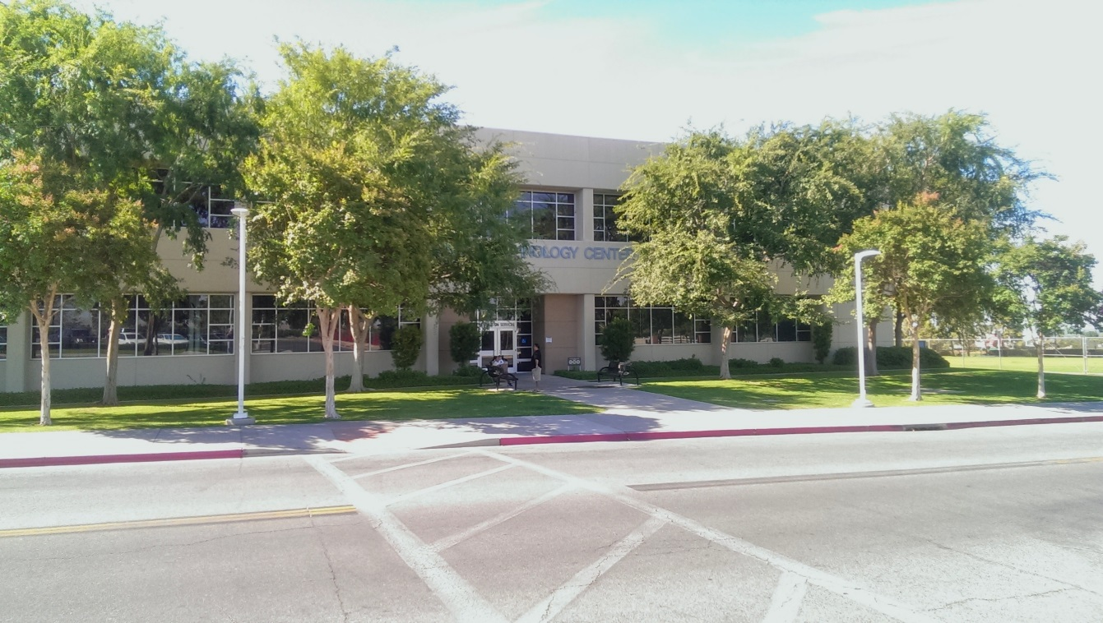

Contents
Overview 2
Mission Statement 2
General 2
Staffing 2
Review of 2014-2017 Technology Plan Initiatives 6
Strategic Objectives 9
1. Support Student Success with Technology 9
2. Support Instruction and Learning through technology 9
3. Improved support for Online Education 9
4. Provide Exceptional Customer Service 9
5. Assessment 9
6. Employee Professional Development 9
7. Develop sustainable technology funding strategies 9
8. Enhance end-user education on security 9
9. Support Green Initiatives 9
2017-2020 Strategic Initiatives Table 10
Appendix A: Governance and Committees 11
Technology Committee (ISIT) 11
District IT Directors Committee 11
Facilities Committee 12
Accessibility Task Force 12
District-Wide Technology Committee 12

Technology Plan 2014-2017

Overview

Mission Statement
Technology Support Services develops, installs, maintains, and supports the technological infrastructure at Bakersfield College. We enable students, faculty, and staff to carry out the mission of the college with greater efficiency and flexibility. We are committed to providing exceptional support to facilitate teaching, learning, training, and campus goals throughout our community.

General
The focus for Bakersfield College as an institution for the next three years is twofold. The first focus is the implementation of Guided Pathways. The Guided Pathways vision is supported by four pillars. The four pillars are Clarify the Path, Enter the Path, Stay on the Path, and Ensure Learning. Each of these pillars is supported by a wide variety of technology. The second focus is the planning, both short and long term, for determining how the technology portion of the Measure J bond money will be used to improve the underlying infrastructure at Bakersfield College.
One of the Institutional goals in the area of infrastructure is to maintain, expand, and take full advantage of technology and equipment in the pursuit of a richer learning experience for the students. The Information Services and Instructional Technology Committee (ISIT), a participatory governance committee, facilitates collaboration from a cross representation of campus constituent groups on technology-related issues in order to identify needs and requirements. The ISIT committee communicates its recommendations to the campus president and/or IT Director and takes issues raised by that committee back to its constituents. The recommendations of this committee are brought to the attention of the appropriate college-governing committees for action.
Underlying all institutional goals is the need to maintain a robust information technology infrastructure and to continue to provide reliable, accessible, high-quality information technology services upon which academic programs, student services, and operations can depend. The Technology Support Services departmental operational plans and goals are updated annually to address changing requirements for providing these services. These plans and goals are guided by the operational plans of other departments, both academic and administrative, and are driven by the Educational Master Plan and the college Strategic Directions.

Staffing
The staff of the Technology Support Services Department is made up of seven Systems Support Specialist I’s, two Systems Support Specialist II’s, one Information Services Coordinator, one Media Services Coordinator, and one Media Specialist. The staff provides support for the Bakersfield College, Delano, and Weill campuses. With over 3000 total computers and a plethora of other network attached devices, this department works diligently to keep things running. The Media Services Coordinator and Media Specialist facilitate the implementation of all media related-equipment requests including setup, video production, interactive instructional and administrative videoconferencing, and video streaming. Staff covers all non-computer related multimedia equipment at the main campus, the Weill Institute, and the Delano Center. Staff also supports the equipment provided for classes at our remote high school locations such as Arvin High School and three Delano High Schools, although we do not have an onsite person. The department is constantly looking for opportunities to improve efficiency, reduce waste, and improve processes to make the technology experience better for the Bakersfield College students, staff, and faculty.
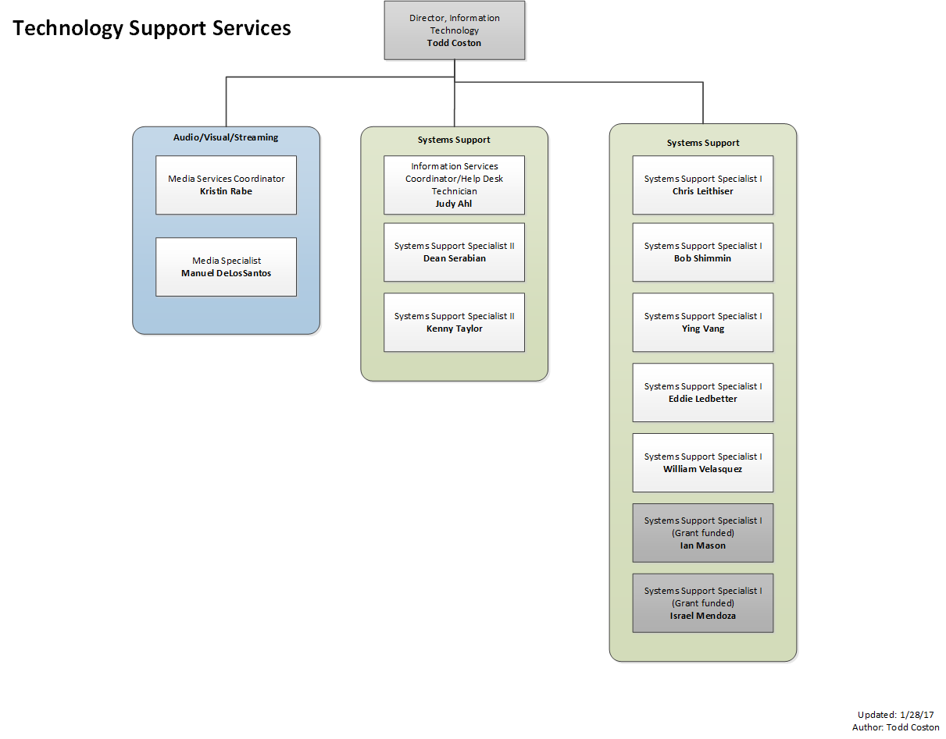
Bakersfield College has over 1200 computers in specialized computer labs supporting student learning outcomes in the areas of math, tutoring services, computer graphics, multimedia, drafting, business, and health sciences. The college has one large, open computer lab with 160 computers located in the library and another 90 computers located on the 2nd floor of the Student Services building used for a large Academic Development and Writing lab.
Bakersfield College recognizes the importance of keeping its computer labs equipped with as up-to-date equipment and software as is fiscally possible. A three- to five-year replacement cycle has been unofficially agreed upon and has been followed as closely as budget will allow. Office computers, with the exception of some used by high-end users, have historically gone longer than three years before replacement. Each department is responsible for reviewing its own needs for upgrading and then utilizing a formal procedure for requesting replacement equipment. The Technology Support Services department, in conjunction with the ISIT Committee, has established and publishes a minimum configuration for all desktops.
Technology Support Services actively participates in district-wide committees and decision relating to technology. The Director, Information Technology, is a member of the IT Managers committee and plays two roles on the committee. The first role is as an advocate for the needs of Bakersfield College, communicating needs and priorities. The second role is to help solve district-wide technology problems and to set standards and provide recommendations for how technology is used within the Kern Community College District. The Director, Information Technology also serves on the Accreditation and Institutional Quality Committee, Presidents Cabinet, Admin Council, Facilities Committee, and Accessibility Taskforce. The Information Services Coordinator participates in the ISIT committee and the Staff Development Coordinating Council. The Media Services Coordinator participates in the facilities planning committee, ISIT Committee, Program Review Committee, and SSSP committee. Also, information is shared within the IT Managers committee relating to district office equipment and software upgrades. Those updates are then communicated to the campus via the ISIT committee or, in some cases, campus-wide communications. More information about IT Staff involvement on campus committees can be found in the Governance and Committees section of this document.
We are consistently looking to best utilize resources and create various replacement policies, which have been suggested to help support technology in the most effective way. Bakersfield College has media equipment stationed in most classrooms on campus and at remote sites and also offers equipment for faculty and staff checkout. When equipment is stolen, we replace with repurposed equipment. We do not replace equipment such as projectors with brand new units unless funding becomes available. A project is created for the ISIT unit plan and it’s added to our request for replacement equipment.
Bakersfield College is a Regional Production Center for the California Community College Satellite Network now known as 3C Media Solutions. Technology Support Services maintains and operates the Bakersfield College video production studio. The facility is available to all faculty and staff for the production of course materials and campus productions. We use Wirecast video production and streaming software that allows us to screen capture during a video production and immediately upload the production once completed with titles and effects. This software also allows us to create a virtual studio environment for our video projects. We continue to develop our streaming media solution involving video production, streaming live events and conferences, closed-captioning for those events, and digital archiving. We have offered live streaming of all of our opening and closing day events for our satellite campus in Delano to participate as well as those individuals who cannot make it to campus.
We support district-wide videoconferencing efforts, both instructional and administrative. We serve as technical support for the four distance education classrooms (two in Bakersfield and two in Delano) and develop and implement policies and procedures for instructional and administrative videoconferences.
Bakersfield College R.I.D.E. (Rural Initiatives Distance Education) program is revitalizing the interactive classroom environment between the colleges and local area high schools. In early 2017, videoconferencing equipment deployed at three Delano area high schools (Delano Unified High School District) and Arvin High School (Kern High School District) will assist the Dual Enrollment Initiative with Bakersfield College. This initiative will allow students currently enrolled in high school to participate in college level coursework without leaving their campuses. The courses will be taught from the Delano campus of Bakersfield College and will cover multiple subjects.
All multimedia equipment used on campus such as projectors, document cameras and other technology are selected by our staff based on the flexibility and reliability of the equipment and the needs of the requesting campus departments.

Review of 2014-2017 Technology Plan Initiatives
 | Specific Initiatives | Results
Classroom technology improvements and standardization | Maintain and update existing technology to meet the development of innovative instructional practices. Develop standards that are broad enough to foster innovation but narrow enough to be able to support. | The technology department has continued to improve existing classrooms in addition to adding several new computer labs (i.e. FA-8, B-5, SE-46, STEM Aera). Additionally, there has been a large influx of iPads for instructional use.
 | Develop new methods and procedures for improving inventory and asset tracking, | The technology department implemented the Dell KACE system for tracking inventory. There are still improvements being made to the inventory process and it is currently meeting the basic inventory needs of the IT department.
 | Work with our District Facilities in the coordination and facilitation of districtwide construction standards for technology and infrastructure. | The District Office is putting together a proposal to have an outside company come in and help us with the development of construction standards. This should be complete by Summer 2017.
Improve wireless access and infrastructure | Continue to expand and improve the wireless access on the Bakersfield College campus with a goal of complete wireless coverage by 2017. | This is a funding issue. The wireless has been improved in some areas but not campus wide. With the passage of Bond Measure J, there is money earmarked for implementing full wifi coverage on the BC campus. It is anticipated that the wifi project will be in the first allotment of funds.
ISIT Technology Requests | Review and maintain current infrastructure and classroom technology by supporting requests made to the Instructional Technology Committee. Prioritize and determine best use of department and college funding to update and maintain technology. | This is an ongoing process that happens every year. The technology committee (ISIT) prioritizes the requests that come from the Program Review process. When money comes available, those requests are funded in the priority order. There is also leveraging of grants to help fund some of the requests.
Video Production and Streaming Framework | Develop a video streaming framework that will encompass live event capture, editing, and digital archiving of materials. This infrastructure will be accessible to the campus community for on-demand training and materials. Review of budget, equipment, and facility needs as required. | This is partially implemented. The primary framework and tool for livestreaming is Ustream, which is provided free by the State Chancellors office. This service is also used to record and archive videos. For other video content, BC relies heavily on YouTube for making videos available. YouTube and Ustream both have tools for adding in captioning to make videos accessible.
Event Coordination | Develop process for seamless event coordination from initial technology request to execution of event at a designated time. Work in tandem with other campus resources to provide technology and coordinate with outside vendors to facilitate equipment if not available in-house. | The IT department has successfully worked with Events & Scheduling on both small and large scale events to address the technology requirements. Depending on the size of the event, sometimes outside contractors are used to aid in the Audio Visual components of our large events.
Support the Academic Technology Roadmap | Develop process and plan work on infrastructure changes needed to develop the Student Success Support Plan (SSSP). Implement a number of new technologies including SARS Alert and Accuplacer. | SARS Alert has been implemented. Accuplacer has been implemented. In addition, the AccuSQL software continues to increase in adoption as the various student support services utilize the tool to capture students using their services (tutoring, writing center, math lab, etc.) Other?
Capital Construction Projects Support | The IT Department provides multiple services related to the construction of new facilities. Services are coordinated with the various departments under the direction of the Maintenance and Operations department and include the following:  - Spend time and effort with the architects and their subcontractors on the building specifications for technology infrastructure  - Interview stakeholders to determine long-term technology needs  - Provide input on bid specifications  - Review bid submissions  - Meeting with the general contractor and subcontractor to review and discuss details of the infrastructure  - Review work completed in conjunction with contract administration  - Work with Purchasing and the colleges on equipment budgets and procurement  - Install equipment in facility (network, computers, phones, audio/visual)  - Assist with moves into the new facilities  There are typically multiple construction projects of various sizes in progress at any given time. IT will continue to provide services for all projects through completion and will maintain the infrastructure after occupancy.  Benefits:  - All work conforms to District IT and campus infrastructure standards  - Sufficient infrastructure ensured for initial needs and potential growth  - All new technology equipment and software is deployed to campus and District standards | The technology department has been involved in several construction related projects. For example, the new STEM Aera building, Fire Alarm Project, Door lock Project, remodel of FA-8, remodel of B-5, development of plans for the Swing Space building, development of plans for the new M&O building, and the list goes on. As momentum builds for the various Measure J bond projects, the technology department will be heavily involved in planning the technology for those spaces.

Strategic Objectives
The purpose of the Strategic Objectives section of this document is to give a brief overview of the technology focus in each of the listed areas. In the next section are specific strategic initiatives that will fall under one or more of the strategic objectives listed in this section.

Support Student Success with Technology
Use technology to provide and enhance student support services enabling greater student access and success.

Support Instruction and Learning through technology
Provide leadership and support for effective, high-quality instruction, and learning outcomes through the appropriate use of technology. Including making content accessible.

Improved support for Online Education
Provide resources and technology tools to better support online students.

Provide Exceptional Customer Service
Enhance responsiveness to end-users. Utilize the ticketing system to track, analyze, and report. Develop improved process for timely and relevant communication to all campus constituents related to planning, improving, implementing, upgrading, or removing campus technology.

Assessment
Analyze current assessment processes and continue to improve those processes.

Employee Professional Development
Provide technology-related professional development opportunities to all employees to improve technology literacy.

Develop sustainable technology funding strategies
Develop funding strategies in order to sustain and enhance mission-critical technologies in times of economic scarcity. Continue to evaluate and develop processes for fair and timely technology allocation. Evaluate Total Cost of Ownership.

Enhance end-user education on security
Proactively provide end-user education to reduce the risk of social engineering and to increase general technology security competence.

Support Green Initiatives
Implement ‘green’ technologies to reduce overall energy consumption and extend hardware lifecycles. Identify opportunities for minimizing the use of printed material and moving to electronic mediums.

2017-2020 Strategic Initiatives Table
Initiative | Result
Expand and improve the wireless access on the Bakersfield College campus with a goal of complete wireless coverage. Measure J money will be used to fund this initiative.
(Strategic Objective 1, 2,)

Review and maintain current infrastructure and classroom technology by supporting requests made to the Instructional Technology Committee. Prioritize and determine best use of department and college funding to update and maintain technology.
(Strategic Objective 1,2,3,4,6,7 )

Develop a video streaming framework that will encompass live event capture, editing, and digital archiving of materials. This infrastructure will be accessible to the campus community for on-demand training and materials. Review of budget, equipment, and facility needs as required.
(Strategic Objective 2,4,7 )

Develop process for seamless event coordination from initial technology request to execution of event at a designated time. Work in tandem with other campus resources to provide technology and coordinate with outside vendors to facilitate equipment and services if not available in-house.
(Strategic Objective 2, 4)

Work collaboratively with the facilities team and Facilities Committee on the new Measure J construction projects.
(Strategic Objective 2, 4, 7, 9)

Predictive Analytics
(Strategic Objective 7,9)

Continue to improve Program Review Process by looking at online forms for resource requests
(Strategic Objective 5, 7)

Appendix A: Governance and Committees

Committee participation is a key part of involvement on the campus. The Director of Information Technology and various staff members are involved in both non-technology and technology related committees to ensure the technology needs of the campus are being met. IT staff participate in non-technology committees such as Program Review Committee, Accreditation and Institutional Quality Committee, Strategic Directions, President’s Cabinet, Administrative Council, College Council and serve as committee co-chairs. Those committees with direct linkage to technology are detailed below.

Technology Committee (ISIT)
The Information Services and Instructional Technology Committee (ISIT) is a participatory governance committee. The committee is co-chaired by a faculty representative and an administrative representative. The current administrative co-chair is the Director, Information Technology. The membership also consists of 7 administrative representatives, 23 Academic Senate representatives, 3 classified representatives and 2 Student Government representatives. Currently, the BC IT Director, IT Coordinator and Media Services Coordinator participate on the ISIT Committee.
The charge of this committee is as follows:
- Recommend campus-wide technology policy and procedures.
- Determine and monitor campus software and hardware standards.
- Allocate technology resources.
- Review all significant technology projects.
- Determine and monitor procedures for obtaining technology services.
- Establish a system of communication between users, district and campus technology resources, and the Academic Senate.
- Assess how well the implementation of new technology resources support institutional goals and improve student success.
- Proposed: Assure that technology support meets the needs of learning, teaching, college-wide communications, research, and operational systems.
- Proposed: Assure that technology planning is integrated with institutional planning.
The scope of this committee is to
Make policy development and implementation recommendations regarding campus-wide technology.
More information on this committee can be found at: http://committees.kccd.edu/bc/committee/isit

District IT Directors Committee
There are seven members of the District IT Managers Committee. The members include the three IT Directors from each campus, two District Office Assistant Directors of Information Technology, the Director of Web Development and the Vice Chancellor of Operations. The Committee typically meets once a month throughout the year and discusses operational issues related to district-wide initiatives.

Facilities Committee
The Facilities committee is a participatory governance committee. The committee membership consists of 3 administrative representatives, 3 faculty representatives, 3 classified representatives and 1 Student
Government representative.
The charge of the committee is as follows:
To review and/or provide recommendations for new and improved facilities and infrastructure improvements to enhance current and future learning environments for students, community, faculty, and staff to the College Council.
The scope of the committee is to provide the President with a venue for reviewing ongoing and proposed projects that impact the physical campus plants and facilities. The scope of this committee will increase with the passage of Measure J: Bond Initiative that passed in November 2016. This will increase funding for various campus construction/revitalization projects across campus and will also provide increased funding for technology in the next twenty years.
More information about this committee can be found at: http://committees.kccd.edu/bc/committee/facilities

Program Review Committee
The Program Review committee is a participatory governance committee. The charge of the committee is to facilitate annual, systematic self-assessment of institutional effectiveness for instructional, student services, administrative and operational areas.
The committee contributes to the “closing of the loop” by disseminating resource allocation requests to responsible committees. The committee reports to College Council annually. The committee is tri-chaired by administrative, faculty and classified representation.

Accreditation and Institutional Quality Committee
The accreditation and institutional quality committee is a shared governance committee charged with ensuring accreditation is an on-going process by guiding preparation of the self-evaluation, midterm and follow-up reports. The committee reviews and monitors collection of evidence and progress on actionable improvement plans and recommendations.
The committee engages, informs and involves the college community in accreditation and institutional effectiveness as well as reviewing and monitoring activities to ensure that they result in integrated, meaningful and sustained college improvement.
More information about this committee can be found at:
https://committees.kccd.edu/bc/committee/accreditation

Strategic Directions Committee
The focus of the strategic directions committee is to develop the three-year cycle document for developing, implementing and evaluating its goals and strategic plan. The deliverables from this committee highlight the developmental process, identified key challenges and describes college goals, data strands and initiatives. The committee has a website that includes the primary strategic directions document as well as supporting materials.
More information about the committee can be found at:
https://committees.kccd.edu/committee/strategic-directions

Accessibility Task Force
The Accessibility Task Force was established to look at all accessibility needs on campus. The Task Force membership consists of Disabled Students Program and Services Director and staff, 3 faculty representatives, classified representatives and administrative representation..
The Task Force looks at all accessibility issues from mobility to providing accessibility to courses. The main objective is awareness. The Vision statement is that Bakersfield College is committed to ensuring that our services are equitable and accessible to all members of your community, including those with disabilities. The Task force strives to engage with faculty, students, staff and community members to identify and explore areas of concern, develop campus awareness, and assist the College in designing and adopting exemplary practices and policies that foster an equitable campus environment.
More information about this Task Force can be found at: https://committees.kccd.edu/committee/accessibility-task-force

District-Wide Technology Committee
The District-Wide technology committee was established to look at all technology projects at each college in the district and what resources are involved in making those projects reality. This is a new committee and the processes and procedures are being developed as this update is being written. There will be representation from each of college (Bakersfield, Porterville and Cerro Coso) and the district office. This committee will assist the district in prioritizing the resources available in making these projects succeed.

