2020-23
Technology Support Services
Bakersfield College
Kern Community College District
Bakersfield College Technology Plan

Contents
Overview 3
Mission Statement 3
General 3
Staffing 3
Review of 2017-2020 Technology Plan Initiatives 7
Strategic Objectives 8
1. Support Student Success with Technology 8
2. Support Instruction and Learning through technology 8
3. Improved support for Online Education 8
4. Provide Exceptional Customer Service 9
5. Assessment 9
6. Employee Professional Development 9
7. Develop sustainable technology funding strategies 9
8. Enhance end-user education on security 9
9. Support Green Initiatives 9
2020-2023 Strategic Initiatives Table 9
Appendix A: Governance and Committees 11
Technology Committee (ISIT) 11
District-wide IT Directors Committee 11
Facilities Committee 12
Program Review Committee 12
Accreditation and Institutional Quality Committee 12
Professional Development Committee 13
Strategic Directions Committee 13
Accessibility Task Force 13
District-Wide Technology Committee 14

Technology Plan 2020-2023

Overview

Mission Statement
Technology Support Services develops, installs, maintains, and supports the technological infrastructure at Bakersfield College. We enable students, faculty, and staff to carry out the mission of the college with greater efficiency and flexibility. We are committed to providing exceptional support to facilitate teaching, learning, training, and campus goals throughout our community.

General
The Bakersfield College Educational Master Plan has several components that have technology implications. One of the first areas is a goal is to scale the Bachelors of Science degree by way of the Early College Program and the Inmate Scholars program. Introducing technology into the prisons is challenging but one that is critical in order for those students to get the hands-on experience they need for the industrial automation degree.
Another focus is the continued development and use of the Programmer Mapper tool. Bakersfield College has earned awards for the development of this tool. Looking ahead, Bakersfield College will utilize the resources and visibility earned through initial innovation to expand its curricular alignment and mapping work to the full CSU system and begin deepening alignment with the University of California (UC) Transfer Pathways. In particular, STEM pathways to UC baccalaureate completion will be of primary focus.
Bakersfield College is in the process of pursuing a new academic scheduling software. The current in-house developed tool is obsolete and runs on antiquated code and hardware systems. This is a project that will have district-wide implications and improve the agility and flexibility of the colleges to schedule classes appropriately and efficiently.
Finally, in addition to the technology plan being aligned with the Educational Master Plan, it is also aligned with the Vision for Student Success goals and the college Strategic Directions.

Staffing
The staff of the Technology Support Services Department is made up of one Director, one assistant director, seven Systems Support Specialists, two Systems Support Specialist IIs, one Information Services Coordinator, one Media Services Coordinator, and one Media Specialist. The staff provides support for the Bakersfield College, Southwest, Delano, and Weill campuses. With over 3000 total computers and a plethora of other network attached devices, this department works diligently to keep things running. The Media Services Coordinator and Media Specialist facilitate the implementation of all media related-equipment requests including setup, video production, interactive instructional and administrative videoconferencing, and video streaming. Staff covers all non-computer related multimedia equipment at the main campus, the Weill Institute, Bakersfield College Southwest and the Delano Center. Staff also supports the equipment provided for classes at our remote high school locations such as Arvin and North High Schools (Kern High School District), three Delano High Schools (Delano Joint Unified School District), although we do not have an onsite person. The department is constantly looking for opportunities to improve efficiency, reduce waste, and improve processes to make the technology experience better for the Bakersfield College students, staff, and faculty.
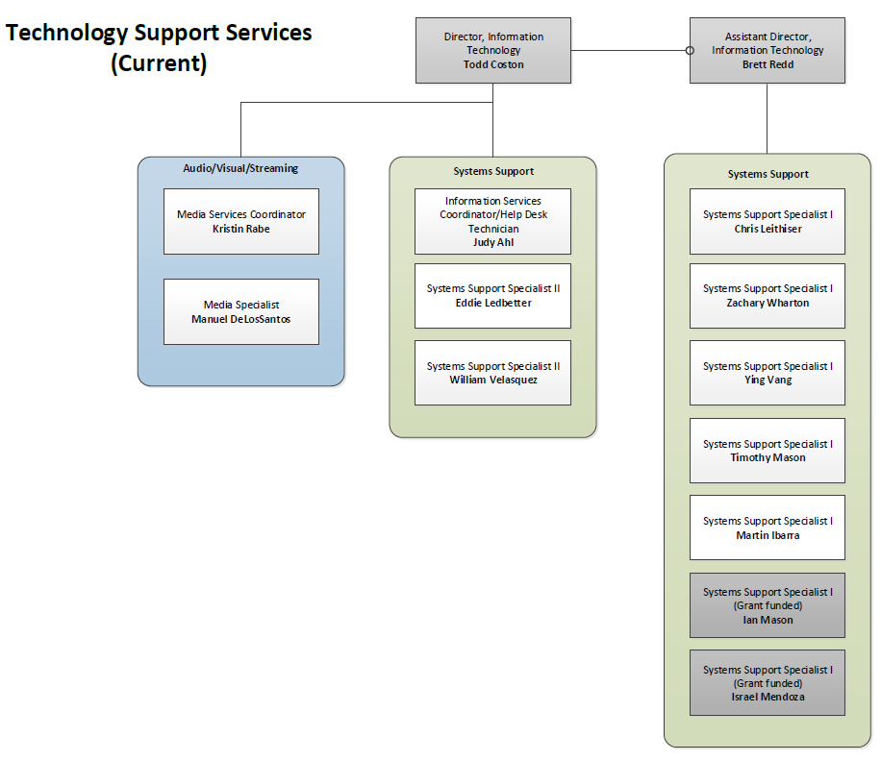

Bakersfield College has over 1400 computers in specialized computer labs supporting student learning outcomes in the areas of math, tutoring services, computer graphics, multimedia, drafting, business, and health sciences. These computer labs and classrooms are spread across multiple sites including the main campus, Delano, BC Southwest, Olive Drive Training Center, Shafter, Arvin, and the Adult School.
Bakersfield College recognizes the importance of keeping its computer labs equipped with as up-to-date equipment and software as is fiscally possible. A three- to five-year replacement cycle has been unofficially agreed upon and has been followed as closely as budget will allow. Office computers, with the exception of some used by high-end users, have historically gone longer than three years before replacement. Each department is responsible for reviewing its own needs for upgrading and then utilizing a formal procedure for requesting replacement equipment. The Technology Support Services department in conjunction with the ISIT Committee has established and publishes a minimum configuration for all desktops.
Technology Support Services actively participates in district-wide committees and decisions relating to technology. The Director and Assistant Director of Information Technology, are a members of the IT Directors committee and play two roles on the committee. The first role is as an advocate for the needs of Bakersfield College, communicating needs and priorities. The second role is to help solve district-wide technology problems and to set standards and provide recommendations for how technology is used within the Kern Community College District. The Director, Information Technology, also serves on the Accreditation and Institutional Quality Committee, President’s Cabinet, Admin Council, Professional Development Committee, and Accessibility Taskforce. The Information Services Coordinator participates in the ISIT committee. The Media Services Coordinator participates in the facilities planning committee, ISIT Committee, and is the Classified co-chair of the Program Review Committee. In addition, information is shared within the IT Directors committee relating to district office systems and software upgrades. Those updates are then communicated to the campus via the ISIT committee or, in some cases, campus-wide communications. More information about IT Staff involvement on campus committees can be found in the Governance and Committees section of this document.
We are consistently looking to best utilize resources and create various replacement policies, which have been suggested to help support technology in the most effective way. Bakersfield College has media equipment stationed in most classrooms on campus and at remote sites and also offers equipment for faculty and staff checkout. If equipment is stolen, we replace with repurposed equipment. We do not replace equipment such as projectors with brand new units unless funding becomes available. A project is created for the ISIT unit plan and it’s added to our request for replacement equipment.
Bakersfield College is known as a Regional Production Center for the state Chancellor’s office 3C Media Solutions. Technology Support Services maintains and operates the Bakersfield College video production studio. The facility is available to all faculty and staff for the production of course materials and campus productions. We use Wirecast video production and streaming software that allows us to screen capture during a video production and immediately upload the production once completed with titles and effects. This software also allows us to create a virtual studio environment for our video projects. We continue to develop our streaming media solution involving video production, streaming live events and conferences, closed-captioning for those events, and digital archiving. We have offered live streaming of all of our opening and closing day events for our satellite campus in Delano to participate as well as those individuals who cannot make it to campus. We are readily using Zoom more effectively for other types of videoconferencing within our infrastructure. ConferZoom is the state Chancellor’s office solution for Zoom which provides each employee with a free professional account.
We support district-wide videoconferencing efforts, both instructional and administrative. We serve as technical support for the nine distance education classrooms (2 BC, 2 Delano, 3 DJUHSD, 2 KHSD) and develop and implement policies and procedures for instructional and administrative videoconferences.
Bakersfield College Early College Initiative successfully piloted an interactive class with North High School during the Spring 2019 semester. The class was successful and further growth is expected for this type of technology within the Kern High School District. Previously, interactive courses were only taught between Bakersfield College and our Delano campus of Bakersfield College through the R.I.D.E. (Rural Initiatives Distance Education) program. In early 2017, videoconferencing equipment deployed at three Delano area high schools (Delano Unified High School District) and Arvin High School (Kern High School District) continues to assist the Dual Enrollment/Early College Initiative with Bakersfield College. This initiative will allow students currently enrolled in high school to participate in college level coursework without leaving their campuses. The courses will be taught from the Delano campus of Bakersfield College covers multiple subjects.
All multimedia equipment used on campus such as projectors, document cameras, and other technology are selected by our staff based on the flexibility and reliability of the equipment and the needs of the requesting campus departments.

Review of 2017-2020 Technology Plan Initiatives
Initiative | Result
Expand and improve the wireless access on the Bakersfield College campus with a goal of complete wireless coverage. Measure J money will be used to fund this initiative.  (Strategic Objective 1, 2,) | The wireless network has been expanded and now covers all internal spaces at all of the BC sites/campuses. There is a follow-on project to update the wireless footprint in all external spaces. This project will stretch out over the next 5 years and will be done in conjunction with all of the new and modernized buildings on campus.
Review and maintain current infrastructure and classroom technology by supporting requests made to the Instructional Technology Committee. Prioritize and determine best use of department and college funding to update and maintain technology.  (Strategic Objective 1,2,3,4,6,7 ) | The ISIT committee has annually collected the Program Review requests and prioritized them based on a committee decided voting process. The priority list along with what was funded each year can be found on the ISIT committee site.
Develop a video streaming framework that will encompass live event capture, editing, and digital archiving of materials. This infrastructure will be accessible to the campus community for on-demand training and materials. Review of budget, equipment, and facility needs as required.  (Strategic Objective 2,4,7 ) | A pilot was done with the Yuja platform but after several months of use, the product did not meet the needs the college wanted. This will remain as an initiative to further evaluate other products.
Develop process for seamless event coordination from initial technology request to execution of event at a designated time. Work in tandem with other campus resources to provide technology and coordinate with outside vendors to facilitate equipment and services if not available in-house.  (Strategic Objective 2, 4) | The process has been improved over the last few years. There is now a weekly meeting to review event requests along with better coordination with outside vendors to provide equipment, support, and expertise for various events as needed.
Work collaboratively with the facilities team and Facilities Committee on the new Measure J construction projects.  (Strategic Objective 2, 4, 7, 9) | The Director, Information Technology and the Media Services Coordinator have both been heavily involved in the design and development of each construction project and continue to stay involved throughout the process.
Predictive Analytics  (Strategic Objective 7,9) | The Starfish platform is in the process of implementation and has a robut analytics component. Additionally, KCCD is pursuing the use of Ad Astra for academic scheduling and that tool also has some predictive analytics.
Continue to improve Program Review Process by looking at online forms for resource requests  (Strategic Objective 5, 7) | The process has been improved by moving to the online software eLumen for both Program Review and resource requests. The tweaking of the online tool will continue with more iterations of Program Review.
Transform the Faculty Development Lab into a state-of-the-art Center for Professional Development with upgraded technology and layout.  (Strategic Objective 2, 3, 6) | The Faculty Development lab has been updated with technology that allows for a wide variety of meetings/events. The technology includes both hardware and software to create flipped classroom content.
Continue engagement in the state-sponsored Online Education Initiative (OEI) with a focus on being a participant in the OEI Course Exchange.  (Strategic Objective 1, 2, 3) | We have been accepted as a member of the OEI Course Exchange and we are working to author our first courses for the exchange.
Collaborate, engage, and support the implementation of the Starfish software.  (Strategic Objective 1, 2, 3, 6) | The campus IT department has been involved in rolling out kiosks and any other equipment to support the rollout of the Starfish software. Additionally, the primary Starfish support person has been included in the help desk ticket system for better routing of Starfish related issues.
Implementation of an online tutoring system utilizing discounted services and platforms offered by the OEI.  (Strategic Objective 1, 3) | The college has adopted the use of the NetTutor program and is actively using the program.

Strategic Objectives
The purpose of the Strategic Objectives section of this document is to give a brief overview of the technology focus in each of the listed areas. In the next section are specific strategic initiatives that will fall under one or more of the strategic objectives listed in this section.

Support Student Success with Technology
Use technology to provide and enhance student support services enabling greater student access and success.

Support Instruction and Learning through technology
Provide leadership and support for effective, high-quality instruction, and learning outcomes through the appropriate use of technology, including making content accessible.

Improved support for Online Education
Provide resources and technology tools to better support online students.

Provide Exceptional Customer Service
Enhance responsiveness to end-users. Utilize the ticketing system to track, analyze, and report. Develop improved process for timely and relevant communication to all campus constituents related to planning, improving, implementing, upgrading, or removing campus technology.

Assessment
Analyze current assessment processes and continue to improve those processes.

Employee Professional Development
Provide technology-related professional development opportunities to all employees to improve technology literacy.

Develop sustainable technology funding strategies
Develop funding strategies in order to sustain and enhance mission-critical technologies in times of economic scarcity. Continue to evaluate and develop processes for fair and timely technology allocation. Evaluate Total Cost of Ownership.

Enhance end-user education on security
Proactively provide end-user education to reduce the risk of social engineering and to increase general technology security competence.

Support Green Initiatives
Implement ‘green’ technologies to reduce overall energy consumption and extend hardware lifecycles. Identify opportunities for minimizing the use of printed material and moving to electronic mediums.

2020-2023 Strategic Initiatives Table
Initiative | Result
Expand and improve the wireless access on the Bakersfield College campus with a goal of complete wireless coverage. Measure J money will be used to fund this initiative.
(Strategic Objective 1, 2,)

Review and maintain current infrastructure and classroom technology by supporting requests made to the Instructional Technology Committee. Prioritize and determine best use of department and college funding to update and maintain technology.
(Strategic Objective 1,2,3,4,6,7 )

Develop a video streaming framework that will encompass live event capture, editing, and digital archiving of materials. This infrastructure will be accessible to the campus community for on-demand training and materials. Review of budget, equipment, and facility needs as required.
(Strategic Objective 2,4,7 )

Work collaboratively with the facilities team and Facilities Committee on the new Measure J construction projects.
(Strategic Objective 2, 4, 7, 9)

Continue to improve Program Review Process by looking at online forms for resource requests
(Strategic Objective 5, 7)

Continue engagement in the state-sponsored Online Education Initiative (OEI) with a focus on being a participant in the OEI Course Exchange.
(Strategic Objective 1, 2, 3)

Appendix A: Governance and Committees

Committee participation is a key part of helping IT staff understand the needs of the college. The Director of Information Technology and various staff members are involved in both non-technology and technology related committees to ensure the technology needs of the campus are being met. IT staff participate in committees such as Program Review Committee, Accreditation and Institutional Quality Committee, Strategic Directions, Facilities, Professional Development, President’s Cabinet, Administrative Council, College Council, and the District IT Directors Committee. Those committees with direct linkage to technology are detailed below.

Technology Committee (ISIT)
The Information Services and Instructional Technology Committee (ISIT) is a participatory governance committee. The committee is co-chaired by a faculty representative and an administrative representative. The current administrative co-chair is the Director, Information Technology. The membership also consists of 7 administrative representatives, 23 Academic Senate representatives, 3 classified representatives and 2 Student Government representatives. Currently, the BC IT Director, IT Coordinator and Media Services Coordinator participate on the ISIT Committee.
The charge of this committee is as follows:
- Recommend campus-wide technology policy and procedures.
- Determine and monitor campus software and hardware standards.
- Allocate technology resources.
- Review all significant technology projects.
- Determine and monitor procedures for obtaining technology services.
- Establish a system of communication between users, district and campus technology resources, and the Academic Senate.
- Assess how well the implementation of new technology resources support institutional goals and improve student success.
- Proposed: Assure that technology support meets the needs of learning, teaching, college-wide communications, research, and operational systems.
- Proposed: Assure that technology planning is integrated with institutional planning.
The scope of this committee is to:
Make policy development and implementation recommendations regarding campus-wide technology. More information on this committee can be found at: http://committees.kccd.edu/bc/committee/isit

District-wide IT Directors Committee
There are ten members of the District IT Managers Committee. The members include the following:
Director, Information Technology (BC)
Asstant Director, Information Technology (BC)
Director, Information Technology (CC)
Director, Information Technology (PC)
Director, IT Infrastructure (DO)
IT Customer Support Operations Manager (DO)
Director, Enterprise Applications (DO)
Associate Director, Enterprise Applications (DO)
Director, IT Security (DO)
Chief Information Officer (DO)
The Committee typically meets once a month throughout the year and discusses operational issues related to district-wide initiatives.

Facilities Committee
The Facilities committee is a participatory governance committee. The committee membership consists of 3 administrative representatives, 3 faculty representatives, 3 classified representatives and 1 Student
Government representative.
The charge of the committee is as follows:
To review and/or provide recommendations for new and improved facilities and infrastructure improvements to enhance current and future learning environments for students, community, faculty, and staff to the College Council.
The scope of the committee is to provide the President with a venue for reviewing ongoing and proposed projects that impact the physical campus plants and facilities. The scope of this committee will increase with the passage of Measure J: Bond Initiative that passed in November 2016. This will increase funding for various campus construction/revitalization projects across campus and will also provide increased funding for technology in the next twenty years.
More information about this committee can be found at: http://committees.kccd.edu/bc/committee/facilities

Program Review Committee
The Program Review committee is a participatory governance committee. The charge of the committee is to facilitate annual, systematic self-assessment of institutional effectiveness for instructional, student services, administrative and operational areas.
The committee contributes to the “closing of the loop” by disseminating resource allocation requests to responsible committees. The committee reports to College Council annually. The committee is tri-chaired by administrative, faculty and classified representation.

Accreditation and Institutional Quality Committee
The accreditation and institutional quality committee is a shared governance committee charged with ensuring accreditation is an on-going process by guiding preparation of the self-evaluation, midterm and follow-up reports. The committee reviews and monitors collection of evidence and progress on actionable improvement plans and recommendations.
The committee engages, informs, and involves the college community in accreditation and institutional effectiveness as well as reviewing and monitoring activities to ensure that they result in integrated, meaningful and sustained college improvement.
More information about this committee can be found at:
https://committees.kccd.edu/bc/committee/accreditation

Professional Development Committee
The focus of the Professional Development committee is to coordinate and support activities to enhance job performance, professional growth, and collegiality among all members of the campus learning community.
More information about this committee can be found at:
https://committees.kccd.edu/bc/committee/pdc

Strategic Directions Committee
The focus of the strategic directions committee is to develop the three-year cycle document for developing, implementing and evaluating its goals and strategic plan. The deliverables from this committee highlight the developmental process, identified key challenges and describes college goals, data strands and initiatives. The committee has a website that includes the primary strategic directions document as well as supporting materials.
More information about the committee can be found at:
https://committees.kccd.edu/committee/strategic-directions

Accessibility Task Force
The Accessibility Task Force was established to look at all accessibility needs on campus. The Task Force membership consists of Disabled Students Program and Services Director and staff, 3 faculty representatives, classified representatives, and administrative representation..
The Task Force looks at all accessibility issues from mobility to providing accessibility to courses. The main objective is awareness. The Vision statement is that Bakersfield College is committed to ensuring that our services are equitable and accessible to all members of your community, including those with disabilities. The Task force strives to engage with faculty, students, staff and community members to identify and explore areas of concern, develop campus awareness, and assist the College in designing and adopting exemplary practices and policies that foster an equitable campus environment.
More information about this Task Force can be found at: https://committees.kccd.edu/committee/accessibility-task-force

District-Wide Technology Committee
The District-Wide technology committee was established to look at technology projects at each college in the district and what resources are involved in making those projects reality. This is a new committee and the processes and procedures are being developed as this update is being written. There will be representation from each of college (Bakersfield, Porterville and Cerro Coso) and the district office. This committee will assist the district in prioritizing the resources available in making these projects succeed.

