Faculty Chairs & Directors Council
March 24, 2023 8:30 a.m. – 10:00 a.m. Levan Center
https://committees.kccd.edu/bc/committee/fcdc

- VPI Updates
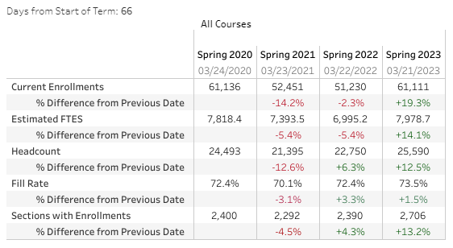

- DE Title V Changes – Menchaca, Rivers

- Program Review: Faculty Requests – Nickell, Rabe

- Student Rights and Grievance Procedures – Damania

- Commencement Update – Wilmot

- Ad Astra: Faculty Schedules – McCauley

- Bookstore Update – McNellis, Jett

- College Council Report – Loken, Stratton

