Faculty Chairs & Directors Council
January 27, 2023 8:30 a.m. – 10:00 a.m. Campus Center Ballroom (East)
https://committees.kccd.edu/bc/committee/fcdc

- VPI Updates
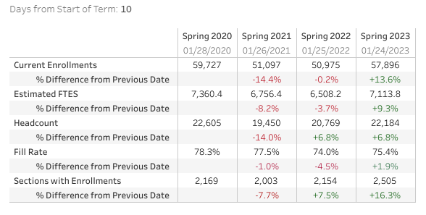

- AED’s – Collum, Knabe, Loken, Mai, Aguirre & Perez

- Reinstate Students within BanWeb – Saldivar

- Title V Update: EW’s and Pass/No Pass – Smith

- Curriculum Update – Hart, Dameron & Wojtysiak

