Faculty Chairs & Directors Council
September 9, 2022 8:30 a.m. – 10:30 a.m. Campus Center Ballroom (East)
https://committees.kccd.edu/bc/committee/fcdc

- VPI/VPSA Update
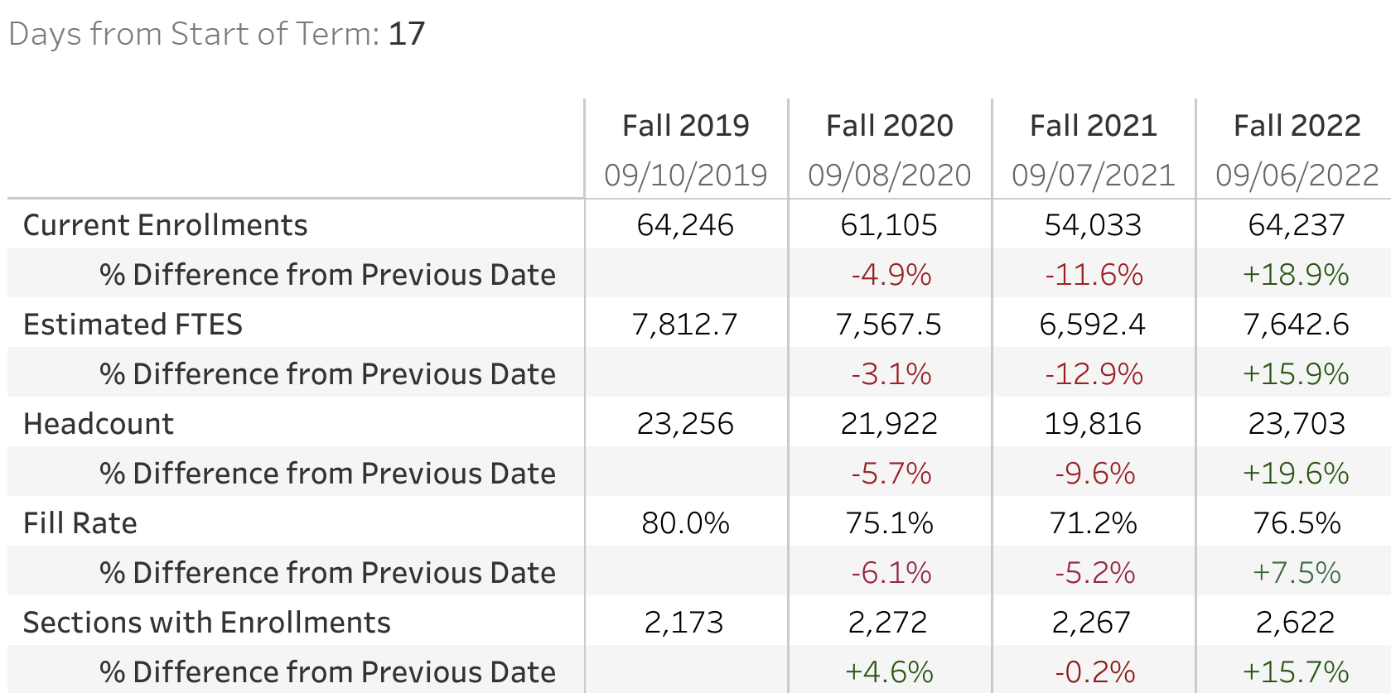

- Finish Fast – Diaz & Marquez

- Keeping Students on the path with LibGuides & Library Instruction – Bradham

- Humanizing Online STEM Academy – Rockey & Zupeda

- New Faculty Resources – Rivers

- Homecoming Events – Ayala & Damania

- Save the Date! Finish-in-4 Convening – Perlado & Marquez

- College Council Report – Stratton & Baltis

