Faculty Chairs & Directors Council

August 26, 2022 8:30 a.m. – 10:00 a.m. CC Ballroom

<https://committees.kccd.edu/bc/committee/fcdc>

* Associate, VPI Updates - Wojtysiak
  + Enrollments
  + 2022-23 Faculty Hiring

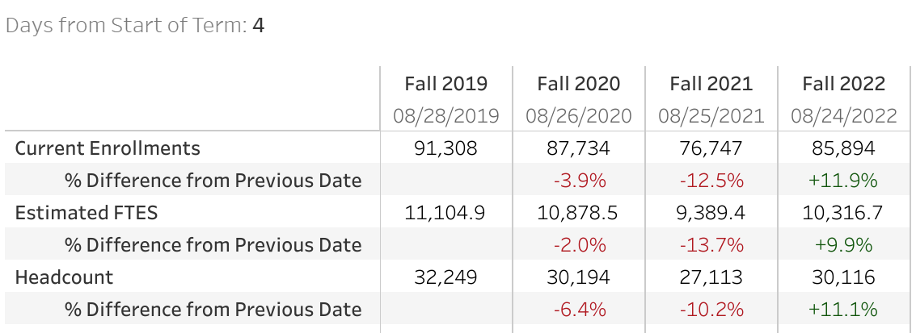

* Spring Scheduling & Ad Astra – McCauley
* Hyflex Update – Redd, Rockey
* Renegade Nexus – Davidson