Faculty Chairs & Directors Council
May 6, 2022 8:30 a.m. – 10:00 a.m. Fireside Room
https://committees.kccd.edu/bc/committee/fcdc

- VPI Update

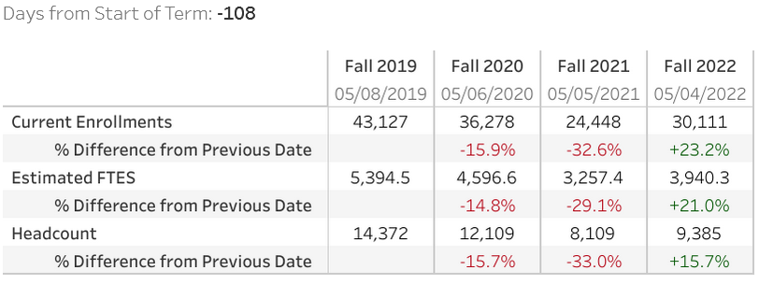

- Dual Enrollment Quality Assurance Workgroup – Saldivar, Campbell, Waller & Jett

- Graduation – Smith & Scott

- 21-22 Wrap Up & 22-23 Planning - Rice

