Faculty Chairs & Directors Council
March 4, 2022 8:00 a.m. – 9:30 a.m. Conference Center
https://committees.kccd.edu/bc/committee/fcdc

- VPI Update – Rice

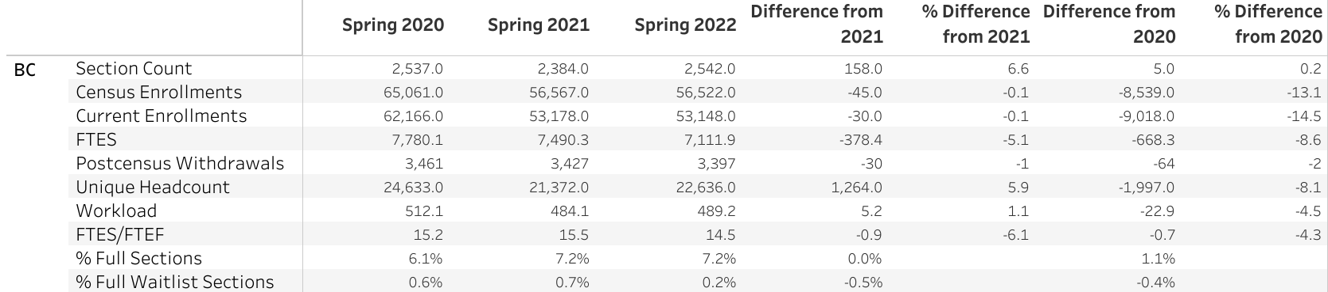

- College Council Report – Stratton & Baltis

- Early College Updates – Campbell

- GP Pillar #3 Staying on the Path – Acosta & Farley

- Bading Skills – Rivers & Moseley

- Regional Collaboration – Cordova

- ACCJC Mid-term Report – Stratton & Miller

- Assessment Committee ILO#2 – Bradham & Waller

- Covid-19 Response Team – Collom & Damania

