Faculty Chairs & Directors Council
January 21, 2022 8:00 a.m. – 9:30 a.m. Zoom
https://committees.kccd.edu/bc/committee/fcdc

- VPI Update - Rice

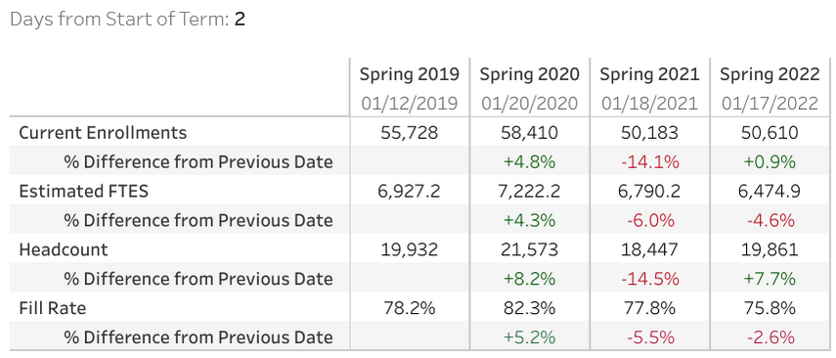

- College Council Report – Stratton & Baltis

- Early College Scheduling Updates – Campbell

- Grant Opportunities – Rosales & Waller

- Articulation, Curriculum & Recent Assembly Bills – Menchaca & Kennedy

- CPL & MAP 2022 Cohort – Menchaca, Nickell, Trujillo, Frank & Doss

- Covid-19 Response Team – Collom & Damania

