Faculty Chairs & Directors Council
December 3, 2021 8:30 a.m. – 9:30 a.m. Zoom
https://committees.kccd.edu/bc/committee/fcdc

- Facilitator - Moseley

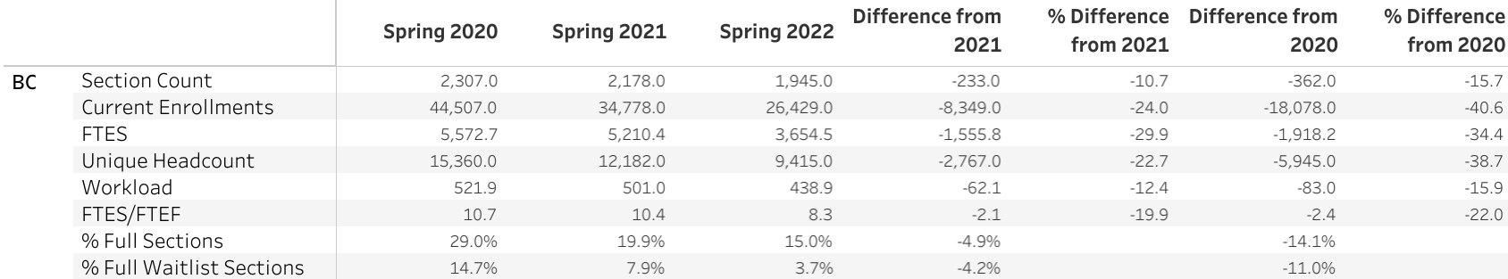

- DSPS Services and Testing – Marquez & Valdez

- Dual Enrollment Quality Assurance – Saldivar, Campbell & Jett

- Covid-19 Response Team – Johnson & Collom

- College Council Report – Stratton & Baltis

