Faculty Chairs & Directors Council
November 19, 2021 8:00 a.m. – 9:30 a.m. Levan Center
https://committees.kccd.edu/bc/committee/fcdc

- Facilitator – Moseley

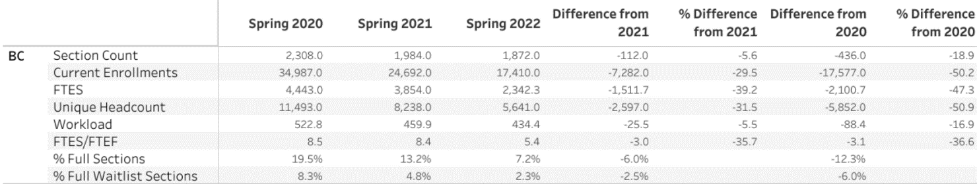

- Admin Structure Review – Moreland, Stratton, McCrow

- Classified Recruitment Prioritzation Process

- College Council Report – Stratton & Baltis

