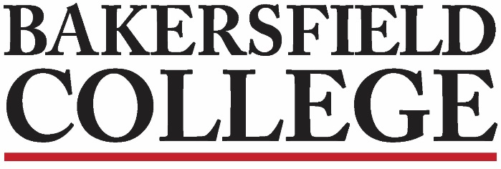
Competency-based Education Implementation Team
7/27/2021
2:00 pm Zoom

Minutes/Notes
Present Members:
Chair: Jessica Wojtysiak (Admin)
Classified Rep: Kim Arbolante
Assessment Rep: Faith Bradham
Curriculum Rep: Erica Menchaca
Union Rep: Ann Tatum
SALT Rep: Marisa Marquez
Management Rep: Michelle Pena
Notetaker: _Ann Tatum________

Absent Members:
Chair: Anna Melby (faculty)
Counseling Rep: Fabiola Johnson
Management Rep: Pamela Rivers
Member at large: Jennifer Johnson

Notetaker/Approval of Minutes  Ann Tatum agreed to take notes.  Minutes from 8/13 unanimously approved. | 5 mins
Chair’s Update  CBE Book Pick up  A few books are left to be picked up. See Yoli in FACE 16 if you have not gotten yours.  Items of Interest/Future Discussion from Jessica’s Meeting with Chancellor’s Office:  - Chancellor’s Office is interested in providing support in articulation with transfer institutions and/or industry partners. If you have ideas, send to Jessica.  - CO does not want certificates, only degrees (either local or transfer).  - Another concern is GE classes. How can they ALL be made CBE? Can there be a mix of CBE and traditional? While initially the answer was “no” (and the book says the same), there seems to be some rethinking of this.  - Transcripts will need to somehow convert the CBE grade to something acceptable (Michelle noted there can only be one transcript due to technical limitations—but a conversion/note of explanation is possible.)  - Fresno Pacific is already showing an interest in taking transfers, more so than the CSUs and UCs. Could private colleges be easier? Local degrees easier? Something to discuss. | 5 mins
What are the qualities of a successful CBE program?  Question Expansion  We went back to the idea of “what qualities do we want to see” and reviewed those questions. Jessica made notes and/or matched the potential application questions to the “qualities” questions. | 45 mins
Homework:  Pick up CBE Book from Jessica’s Office  Read another 2 chapters that interest you most.  - Review the questions and notes, make suggestions, start smoothing out the language. REMINDER: the application will need to be ready by Flex Week!  - We did not discuss reading the book, but I am sure you can if the spirit moves you. (:  Next Meeting: Tuesday, August 3rd at 2:00 pm | 5 mins
Save the Dates! CBE Collaborative
Calendar of Peer Learning Sessions
2020-21

2021
August 18th
10:00am-1:00pm

October 4th
10:00am-1:00pm

November 30th
10:00am-1:00pm

2022

January 17th
10:00am-1:00pm

March 16th
10:00am-1:00pm

May 11th
10:00am-1:00pm

