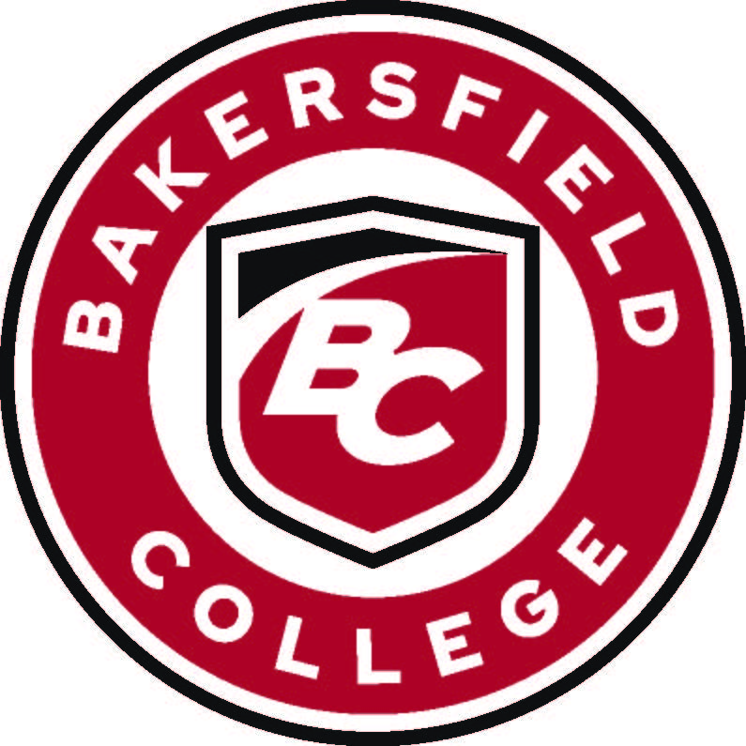
Bakersfield College Council
Meeting Minutes – March 5, 2026
1:30 – 2:30 p.m. | Campus Center Boardroom
Supporting documents available at: https://committees.bakersfieldcollege.edu/college-council

I. Call to Order and Members Present
The College Council meeting was called to order at 1:30 p.m. by Interim Vice President of Instruction, Jessica Wojtysiak

Present: Queen King, Andrea Thorson, Ashlea Ward, Jessica Wojtysiak, Leo Ocampo, Ann Tatum, Rebecka Zepeda, Grace Commiso, Kimberly Bligh, Michael Korcok, Faith Bradham, Victor Crosthwaite

Regrets: Stacy Pfluger, Cesar Jimenez, Sooyeon Kim, Heather Baltis, Nick Strobel, Marcia Overturf, Maria Arias, Khalfani Mackey Vacant (Vice President of Instruction), Vacant (Classified Representative, Finance & Administrative Services)

Others Present: PJ Delgaudio

II. Approval of Minutes
The minutes from February 5, 2026, College Council meeting were reviewed.
Motion: To approve the minutes as submitted.
First: Andrea Thorson | Second: Kimberly Bligh | Motion Carried.

III. President’s Update
Vice President Wojtysiak provided general college updates, including current initiatives, recent campus activities, and engagement efforts. Highlights included:
- Bakersfield College has been recognized as a Leader College of Distinction by Achieving the Dream, reflecting sustained and expanded progress in student retention, completion rates, and the college’s use of data to guide decision-making.
- College Council will vote on the 2025–26 Administrative Structure Review at today’s meeting. Dr. King will begin the 2026–27 Administrative Structure Review, which will be completed before July 1. College Council faculty members were invited to volunteer for the Administrative Structure Review Task Force, and Kimberly Bligh, Michael Korcok, and Heather Baltis agreed to serve. The committee is also considering renaming the task force, and College Council members were asked to submit name suggestions to Catherine.

IV. Reports to College Council

A. Committee Charges (Consent Items)
The following committee charges were presented for review and approval under consent:
- None

B. Committee Reports (Information Items)
Informational reports were shared from the following committees:
- Accreditation & Institutional Quality Committee Report
- Bookstore Advisory Committee Report
- Curriculum Committee Report
- Enrollment Management Committee Report
- Equivalency Committee Report
- Online Teaching Guidelines Proposal for RSI
- Program Review Committee Report
- Technology Committee Report
Presenter: Rebecka Zepeda
Reports were received and filed for information only.

V. College Council Business

C. Administrative Structure Review
No feedback was received since the first reading at the previous meeting.
Presenter: Queen King
Motion: To approve as submitted.
First: Ann Tatum | Second: Rebecka Zepeda | Motion Carried.

D. Event Space Black Out Dates
The calendar was created in response to increased event space demand for campus spaces from external partners. Its purpose is to help manage weekend and holiday requests, including the designation of firm blackout dates; however, exceptions may be granted with approval from the President’s Office.
Presenter: PJ Delgaudio

E. Distance Education Review Council Charge Proposal
A new operational group was approved by the Academic Senate at their last meeting. This council will take over the course review process currently done by AIQ and maintain the Distance Education Handbook.
First Read. Committee will vote to approve at next meeting.
Presenter: Rebecka Zepeda

F. Military Absence Request Form
A district-wide form approved by the Academic Senate was reviewed. Concerns were raised regarding the accommodation language, and the group requested that Jenny Frank verify whether the wording reflects state-required language.
First Read. Committee will vote to approve at next meeting.
Presenter: Jessica Wojtysiak

VI. Information Items
Campus Events and Dates to Note:
A summary of key upcoming campus activities was shared, including:
- BC/CSUB – March 6, Edward Simonsen Indoor Theater
- 18th Annual Sterling Silver Gala – March 14, Renegade Event Center
- Women’s History Monty Movie Screening – March 18, Fireside Room

Full listings are available through the Bakersfield College Events Calendar and the Renegade Athletics Schedule.

Adjournment
The meeting was adjourned at 2:08 p.m.
The next scheduled College Council meeting will be held on Thursday, March 19, 2026, at 1:30 p.m. in the Campus Center Boardroom.

