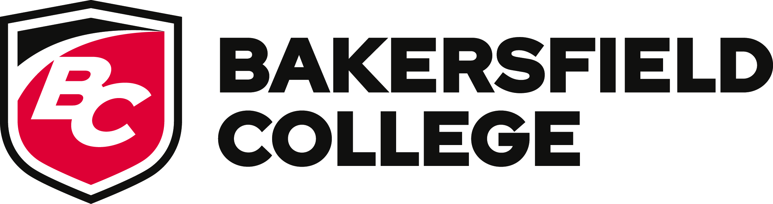
Bakersfield College Council
Meeting Minutes – October 23, 2025
1:30 – 2:30 p.m. | Campus Center Boardroom
Supporting documents available at: https://committees.bakersfieldcollege.edu/college-council

I. Call to Order and Members Present
The College Council meeting was called to order at 1:33 p.m. by President Stacy Pfluger

Present:
Stacy Pfluger, Queen King, Andrea Thorson, Ashlea Ward, Leo Ocampo, Sooyeon Kim, Ann Tatum, Rebecka Zepeda, Grace Commiso, Kimberly Bligh, Nick Strobel, Faith Bradham, Zachary Wharton, and Maria Arias.
Regrets:
Cesar Jimenez, Jessica Wojtysiak, Heather Baltis, Marcia Overturf, Khalfani Mackey, Vacant (Vice President of Instruction), Vacant (Classified Representative, Finance & Administrative Services)
Others Present:
Jennifer Jett (Proxy for Jessica Wojtysiak), Hunter Moore (Proxy for Khalfani Mackey)

II. Approval of Minutes
The minutes from the October 2, 2025 College Council meeting were reviewed.
Motion: To approve the minutes as presented.
First: Andrea Thorson | Second: Grace Commiso | Motion Carried.

III. President’s Update
President Pfluger provided general college updates, including current initiatives, recent campus activities, and engagement efforts. Highlights included:
- Kern-AUCC Health Scholars Pathway on Monday, October 27th
- Project Hire Up Cohort 16 Graduation
- October 31st is KCCD Chancellor’s Town Hall and BC Fall Social

IV. Reports to College Council

A. Committee Charges (Consent Items)
The following committee charges were presented for review and approval under consent:
- Equal Opportunity & Diversity Advisory Committee (EODAC) Charge
- Program Review Committee Charge
Presenter: Rebecka Zepeda
Motion: To approve the committee charges as presented.
First: Andrea Thorson | Second: Grace Commiso | Motion Carried.

B. Committee Reports (Information Items)
Informational reports were shared from the following committees:
- Curriculum Committee
- Enrollment Management Committee
- Equivalency Committee
- Program Review Committee
- Safety Advisory Committee
Presenter: Rebecka Zepeda
Reports were received and filed for information only.

V. College Council Business

C. Distance Education Handbook
Presenter: Andrea Thorson
The Council received an informational update on the Distance Education Handbook.
Action: The Council will review proposed revisions at an upcoming meeting.

VI. Information Items
Campus Events and Dates to Note:
A summary of key upcoming campus activities was shared, including:
- CSU Application Workshop – October 24, Fireside Room
- BC Football vs. East Los Angeles – October 25, Memorial Stadium
- Financial Aid Workshops, Music Recitals, Volleyball and Soccer matches, and the First-Generation College Celebration on November 6
- Bakersfield College Rodeo – November 8–9, Kern County Fairgrounds
- International Education Week Showcase – November 18
- Vet Fest – November 19
Full listings are available through the Bakersfield College Events Calendar and the Renegade Athletics Schedule.

Adjournment
The meeting was adjourned at 2:34 p.m.
The next scheduled College Council meeting will be held on Thursday, October 30, 2025, at 1:00 p.m. in the Campus Center Boardroom.

