Bakersfield College Homecoming 2015

The BC Homecoming Committee is working hard to make Homecoming 2015 the best celebration to show off the Renegade Pride! Only with your enthusiastic and committed participation, Homecoming 2015 will be an exciting and enjoyable event. This year the Homecoming 2015 theme is:

“Shades of the Renegade: #The BC Collage”
Monday, October 12th thru Saturday, October 17th

While many of the events are open to individual participation, the BC Homecoming Committee encourages you as the BC community to form teams and show off our BC spirit and pride with new and old traditional homecoming events. Visit the Homecoming website for more information at: https://www.bakersfieldcollege.edu/homecoming

This year’s theme and activities are centered on the combination of various art forms and how everyone may see different things from the same art. Show your BC Renegade Pride by participating in any of the special events planned. Also show your Renegade Spirit by posting your #theBCCollage to Instagram or Twitter, and we will share your photos on Bakersfield College’s social media.

In order to save you time and have a prosperous homecoming experience, the BC Homecoming Committee advises you to read each section of the packet thoroughly and carefully for the rules and the events for Homecoming 2015. All members must abide by all regulations and safety guidelines for Homecoming 2015 and the BC Code of Conduct.

Thank you and best of luck in the Homecoming 2015 competition!

GO Gades Go!
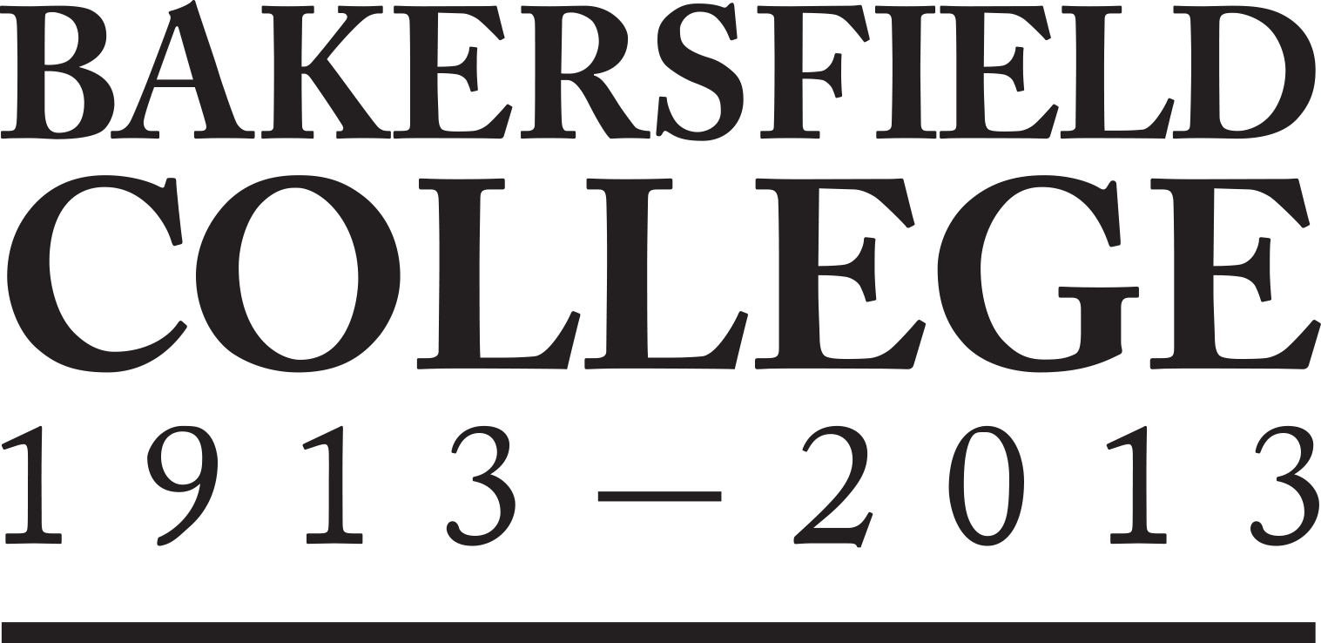
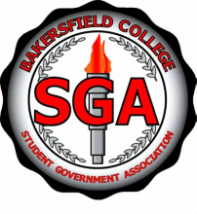

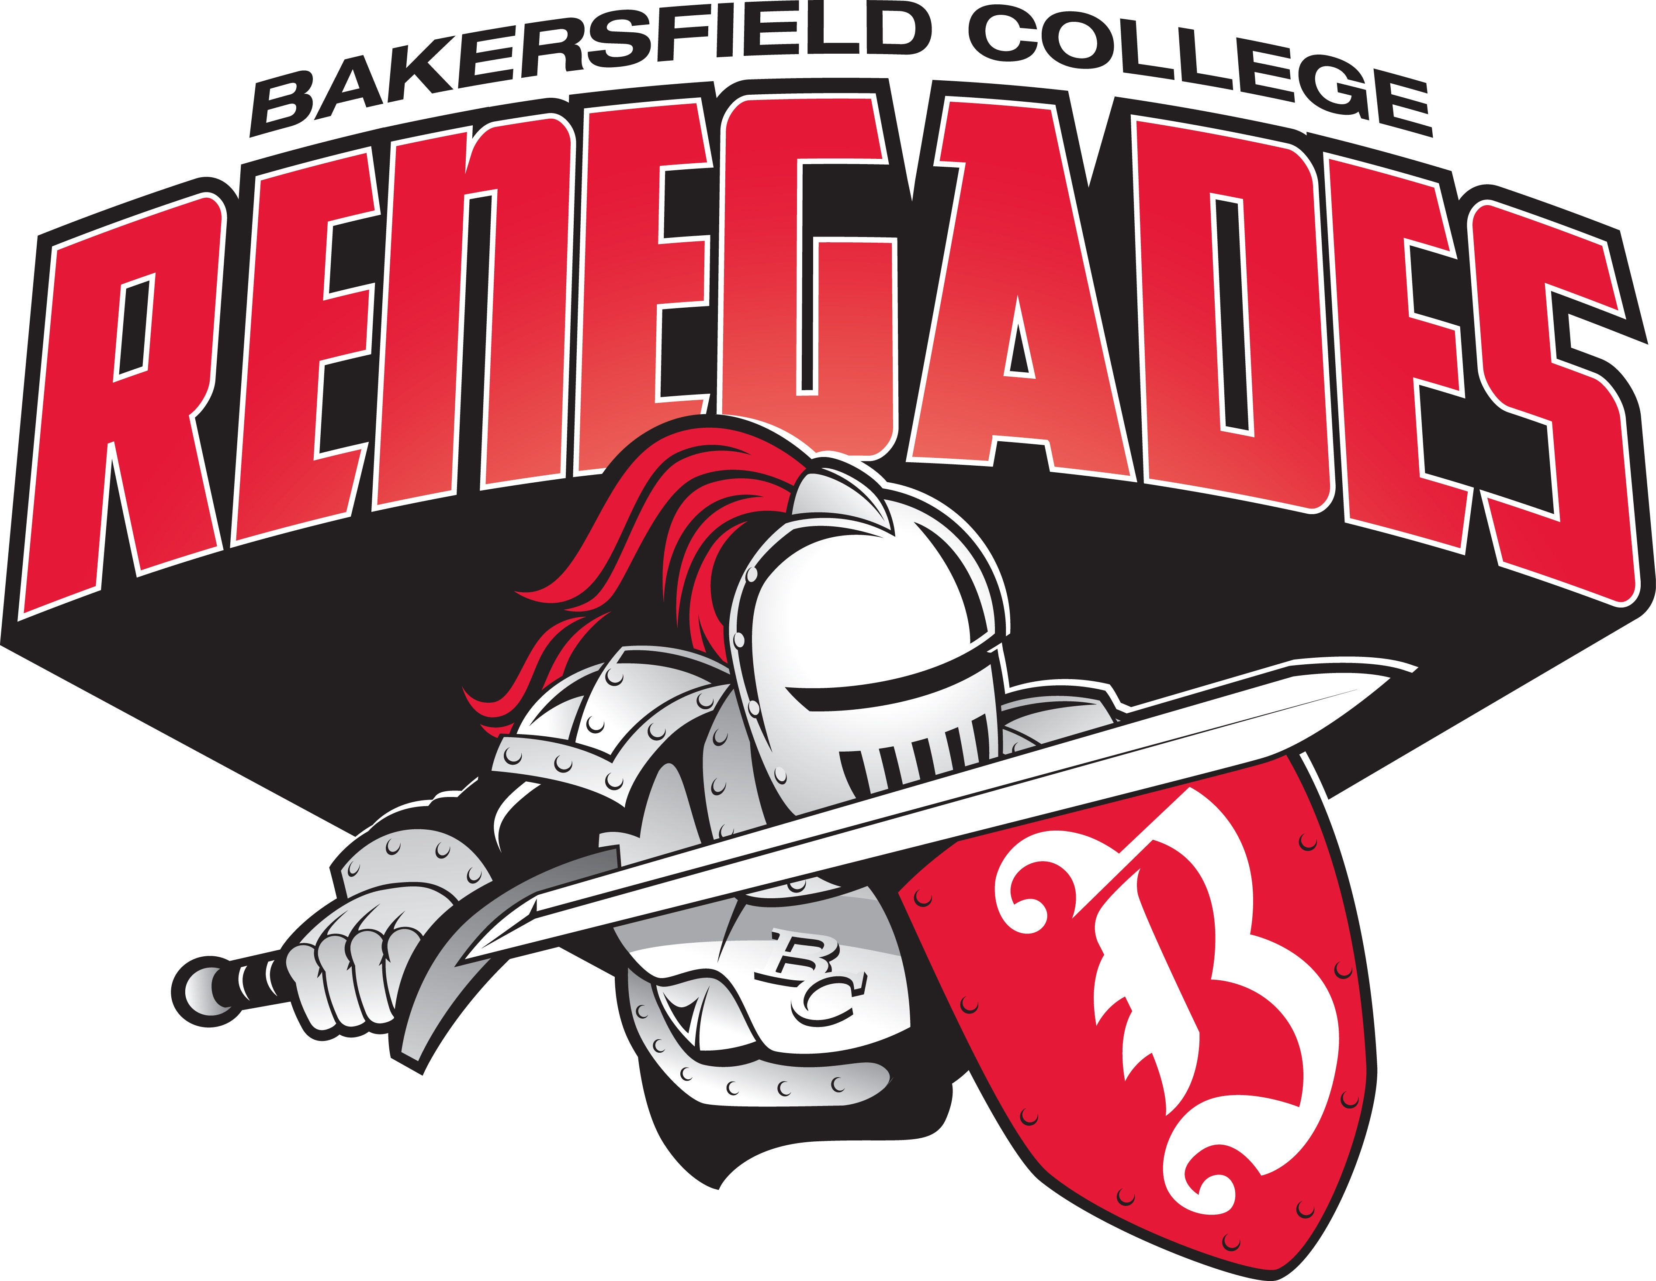

Individual versus Team Competition

While each Homecoming event may have its own prize or incentive to attend or participate, this year there will be the opportunity to compete as a team throughout the week. Individuals are also highly encouraged to participate in the various activities.

All teams need to be composed of at least 5 BC students, staff, classified, faculty, or BC alumni. Verification of team members may be requested at any time. In order to register, your team will need to submit a complete roster of participants. This will be crucial for success especially in regards to attendance-based events. We encourage you to branch across all departments of campus and the community when selecting your team members.

Various team points are given at each event. A running total of points per team will be posted on the Homecoming Website. Teams are not required to participate in every event, but are highly encouraged. The winner of the Team Competition will receive the Red&White traveling trophy and an individual award.

To register your team, please complete and submit the Homecoming Team Application 2015 found online at https://bcstudentlife.wufoo.com/forms/homecoming-team-application

Homecoming Event | Individual | Team Competition
Pre-Homecoming Meeting |  | X
Homecoming Royalty Court | X | X
BC Channel video | X | X
Renegade Poster Pride |  | X
Attend Alumni Speaker President |  | X
BC Got Talent | X | X
Rally of the Renegades |  | X
Renegades Care | X | X
Rage of the Renegades’ Homecoming Parade |  | X
Homecoming Football Game |  | X

Mandatory Pre-Homecoming Meeting

BC Homecoming Committee will be hosting three options for a MANDATORY meeting for all participating teams to accommodate busy schedules. The Meetings will be held in the BCSGA Executive Board Room, Campus Center, Room 5.

The Team Captain for your team MUST attend ONE of them:

- Monday, October 5, 2015, at 11 a.m.
- Tuesday, October 6, 2015, at 3 p.m.
- Wednesday, October 7, 2015, at 5 p.m.
- Thursday, October 8, 2015, at 5 p.m.

For more information, contact the Office of Student Life:
PHONE: (661) 395-4614
EMAIL: studentlife@bakersfieldcollege.edu
Website: www.bakersfieldcollege.edu/homecoming

2015 Homecoming Royalty Court

Homecoming Royalty is an honored and longstanding tradition of Bakersfield College’s Homecoming celebration. The Royalty nomination and selection process is a tremendous opportunity to showcase and recognize a few of the many outstanding students at Bakersfield College. The Homecoming Royalty Court is comprised of four (4) students who shall represent the College and student body at various campus and community events throughout the year.

The selection process for the Homecoming Royalty Court is based upon leadership activities, academic achievement, and campus involvement. An essay, resume, and head shot must be completed as part of the application process. All nominees will be initially interviewed and screened by a panel of judges, whom will select a maximum of 12 candidates for a title of the BC Royalty Court. Please note that the Homecoming Court selection process is not a beauty pageant or a popularity contest. Royalty will be screened and ultimately selected based on the applicants’ ability to articulate and demonstrate academic performance, curricular and co-curricular involvement, contributions to the College as well as the Bakersfield Community, and BC Renegade Spirit.

While anyone can nominate a student or self-nominate, the Homecoming Competition Teams have the opportunity to nominate a maximum of two individuals they feel who exemplifies the BC Renegade Spirit. A nominee does not need to be a member of a team, but the nominee can only represent one team.

To be an applicant for Homecoming Royalty Court, candidates must agree to the following:
- Must be a current registered Bakersfield College student enrolled in six or more credits and must have a cumulative GPA of 2.0 or higher.
- Must be in good standing with Bakersfield College (no current judicial sanctions). All past judicial sanctions will be reviewed by the Director of Student Life to determine eligibility.
- Candidates cannot be sponsored by College funded or governing organizations (Student Government, Academic Departments, Renegade Rip, etc.) but can be sponsored by registered student organizations
- Must provide a typed 500-word essay stating the candidate’s school spirit and why the candidate should be selected as Homecoming Royalty, along with a current resume and professional head shot.
- If a candidate is found to be under the influence of alcohol or illegal substances before or during any event, the candidate will be withdrawn from the competition. All candidates must abide by the Student Code of Conduct.

All Candidates must:
- Attend a Mandatory Pre-Homecoming Team Meeting
- Attend designated Homecoming activities
- Be able to be photographed and filmed
- Participate in the BC Got Talent event
- Participate in the Homecoming 2015 parade
- Attend the Homecoming Football Game and participate in homecoming activities at halftime

Nominations: To nominate a student, email studentlife@bakersfieldcollege.edu

Application: https://bcstudentlife.wufoo.com/forms/homecoming-court-application

Application Deadline: Each interested candidate must complete the only application by
Friday, October 9, 2015, by 11:59 a.m.

Candidate Timeline and Requirements:
Attend a Mandatory Pre-Homecoming Meeting Various Times and days
Interview with the Judges By appointment week of October 5th
Notification of Candidacy Friday, October 9, 2015
Candidates can start advertising Saturday, October 11, 2015
Submit BC Channel video Monday, October 12, 2015
Attend Alumni Speaker President Tuesday, October 13, 2015
BC Got Talent Wednesday, October 14, 2015
Rally of the Renegades Thursday, October 15, 2015
Renegades Care Friday, October 16, 2015
Rage of the Renegades’ Homecoming
Parade and Homecoming Football Game Saturday, October 17, 2015

Selection Criteria: 25% Leadership Activities
25% BC Involvement
25% Academic Achievement
25% Presentation and Attitude

Voting: Voting for the 2015 Homecoming Royalty Court will be held from Noon on Thursday, October 23, 2015 until 6 p.m. on Friday, October 24, 2015 via online. The candidates with the most votes will be deemed the 2015 Homecoming Royalty Court at the Football Halftime show on Saturday, October 25, 2015. The link to the voting site will be posted at https://www.bakersfieldcollege.edu/homecoming

Individual Incentive: The four students selected for the Court also are eligible to receive a $100.

Team Competition: 500 points will be given to each team whose nomination was voted into the Royalty Court.

Renegade Poster Pride and Office Decorations

Teams and BC Departments will have the opportunity to decorate a poster board in the Campus Center or their office space in the spirit of this year’s homecoming theme.

Event Criteria:
- Posters/Office are judged on creativity, spirit, and Renegade Pride.
- One white blank poster board and some supplies will be provided
- Posters/Offices that are offensive or in bad spirit will be disqualified.

Event Details: Monday, October 12, 2015
9 a.m. - 3 p.m. | Campus Center and Individual Office Areas
Office Incentive: A catered lunch party.

Team Competition: Team Entry: 200 points
Third Place: 300 points
Second Place: 400 points
First Place: 600 points

The judges will be around at their own convenience after 3 p.m.
It is not required that your team be present.

BC Channel Competition

This is your chance to show BC what Renegade Pride means in any spirited way. Support the Gades by showing how much BC Pride you have in a 15-second video. These videos will be publicly showcased. All individuals within the video must have given their permission to be filmed and publicly broadcasted.

Event Criteria:
- Videos are judged on creativity, spirit, and Renegade Pride.
- Videos that are over 15 seconds will be disqualified.
- Videos can include as many individuals as you want.
- Videos that are offensive or in bad spirit will be disqualified.

To submit your team’s videos:
- Upload the video to YouTube.com under your personal account
- Send an email with the hyperlink of the video

Submission Deadline: Tuesday, October 13, 2015
5:30 p.m. | studentlife@bakersfieldcollege.edu

Voting: Voting for the Best BC Channel spot will be held from Noon on Wednesday, October 14, 2015 until 6 p.m. on Friday, October 16, 2015 via online. The link to the voting site will be posted at https://www.bakersfieldcollege.edu/homecoming

Individual Incentive: $50

Team Competition: Team Entry: 200 points
Third Place: 300 points
Second Place: 400 points
First Place: 600 points

Homecoming Alumni Speaker featuring… Jeremy Staat

The 2015 Alumni Speaker presents Professor Jeremy Staat. Mr. Jeremy Ray Staat (Bakersfield native) is a former American Football defensive end who played for the Pittsburgh Steelers in 1998 and the St. Louis Rams for two games in 2003. He also played for the Los Angeles Avengers arena football team. He is a United States Marine, and has served in Iraq. Bakersfield College is proud to have Mr. Staat as part of the esteemed faculty, teaching Welding.

Event Details: Tuesday, October 13, 2015
Noon | Cafeteria, Campus Center

Individual Incentive: Listen to an amazing and inspirational story.

Team Point Values: Third Place: 200 points
Second Place: 300 points

First Place: 500 points

Team members will need to check in at the SGA table at the beginning of the event. Members will be cross-referenced with the team roster, thus a picture id maybe needed. Team members may also bring additional guests for a larger attendance record. The team with the highest number of attendees will be awarded points.

BC Got Talent

The BC Got Talent event is one of this college’s new traditions. Performers will be judged by a panel. Performances can be centered around a spirited routine, comedy act, magic show, vocal or instrumental performance, etc., as long as it is appropriate and in good taste. Just a tip…judges love when acts include the homecoming theme and when the performers have a large support group.

Event Criteria:
- All acts are limited to a 4-minute performance (max).
- The lineup will be at random and determined at event; hence, all groups must stay for the duration of the event (approximately 2 hours).
- Performers must be present in the Office of Student Life by 4:45 p.m.
- Acts will be provided one microphone and a simple CD player, all other technology or props must be supplied by the performers

Event Details: Wednesday, October 14, 2015
5:30 p.m. | Cafeteria, Campus Center

Registration form: https://bcstudentlife.wufoo.com/forms/homecoming-bc-got-talent

Individual Incentive: $75 to the individual who wins the competition.

Team Point Values: Team Entry: 200 points
Third Place: 200 points
Second Place: 300 points
First Place: 500 points

At least one of the members on the rooster must be participating in the act. Other individuals outside of the team rooster are eligible to perform as well.

Rally of the Renegades

Get fired up about Bakersfield College and the Homecoming Football Game. Come enjoy some hot pancakes while listening to some local musical acts, interact with the BC Drum Core, participate in an array of games, watch a dancing troupe performance, get painted, and much more.

Event Details: Thursday, October 15, 2015
12:30 p.m. | Renegade Stage, Campus Center
(Booth needs to be set up by 11:30 a.m.)

Event Criteria:
- Teams are strongly encouraged to host a booth that is practical, simple, and original for carnival entries and encourages teams to enter basic carnival games—for examples, a football, ring toss, go fishing, duck pond, or basketball toss or dart throw – or something inexpensive and creative.
- Here is a site with great ideas: http://www.carnivalsavers.com/freeboothideas.html
- Since children and alumni may attend, teams are encouraged to show Homecoming spirit by wearing Homecoming and BC gear, and giving their game booth a creative Homecoming flavor.

Team Point Values: Booth Entry: 300 points
Best Booth: 500 points
Spirited Booth: 500 points

Renegades Care

The Student Government Association at Bakersfield College saw a growing need among students on Campus and determined that the food bank was needed to better serve the students. The Renegade Pantry’s main goal is to help maintain the health and welfare of Bakersfield College students through organized college, community sponsorships and donations of nonperishable food items. You can contribute by donating non-perishable items or clothing items by taking them to the Office of Student Life. We also accept money donations.

Collection Times: All week Monday thru Thursday, 8 a.m. to 5 p.m. and Friday 8 a.m. to Noon
Donations must be dropped off at the Office of Student Life.
Please call (661) 395-4614, if you need assistance in transporting items

Deadline: Friday, October 16, 2015
Noon | Office of Student Life, CC4

Individual Incentive: For every 5 items an individual brings, one voucher to a 2015 BC Home Football game will be given, this includes the 2015 Homecoming Game (10/25/14) or 11/4/14.

Team Point Values: For each nonperishable food item donated the team will receive five points
For each clothing item donated, the team will receive ten points

Rage of the Renegades’ Homecoming Parade

This is the final celebration before the big game! This year marks the beginning of a new tradition. The Office of Student Life encourages all teams and community entities to go above and beyond this year, and make the walkable floats that are eye-catching for all of the spectators.

Entries must use the Homecoming theme into their floats. Floats will be judged on creativity, visual appeal, and engagement. Please begin construction of your float early so it is exciting. Please put some time and effort into these.

The Office of Student Life reserves the right to revoke any entry from the parade if the entry or team members are not abiding to the parade rules listed in this Homecoming 2015 packet or at the discretion of the Director of Student Life.

Event Criteria:
- Floats are judged on creativity, spirit, and Renegade Pride
- Floats are walkable, no vehicles or trailers
- Floats can include as many individuals as needed
- Floats built by students or student organizations who may need additional assistance, please email studentlife@bakersfieldcollege.edu with your request
- Floats that are offensive or in bad spirit will be disqualified
- Float Members must all abide by the Parade Rules

Event Details: Saturday, October 17, 2015
12:30 p.m. | Northwest Parking Lot – Admin/Faculty Parking Lot

Registration Form: bcstudentlife.wufoo.com/forms/2015-homecoming-parade-registration

Individual Incentive: Best Use of Theme: $100
Most Spirited: $100

Team Point Values: Team Entry: 400 points
Third Place: 600 points
Second Place: 800 points
First Place: 1000 points

2015 Homecoming Football Game

Come out and support our very own Bakersfield College Football team The Renegades as they stomp on the Cerritos College’s team. Be a true Knight with your Red and White!

Event Details: Saturday, October 17, 2015
6:00 p.m. | Bakersfield College Memorial Stadium

Halftime Show: Accouchements will be made regarding the coordination of the 2015 Homecoming Court as well as the winners of the 2015 Red&White Team Competition!

The Parade Rules:

- Check in will begin at Noon on Saturday, October 25, 2015, and all entries must be checked in by 12:30 p.m. Any entry not checked in at this time will not participate in the parade. Floats and participants must check-in and be present at the BC Northwest Parking Lot – Admin/Faculty Parking Lot located by Panorama Drive and Haley.
- The route of the parade will be through the internal routes of the campus grounds.
- Only one representative from each team will register their entry.
- All entries will be inspected by the Department of Public Safety.
- Floats that fail to comply with any federal, state, and local laws, or are in any way offensive in nature will be dismissed from the parade by Police and will be disqualified from the homecoming competition.
- No alcohol or drugs are to be present or consumed at any time. Anyone violating the alcohol policy, displaying unsportsmanlike conduct or any other disruptive or inappropriate behavior will be turned over to the Police and/or the Office of Student Life.
- Nothing shall be thrown, sprayed or discarded along the parade route (includes candy, rice, etc.) for the safety of the spectators. Participants are welcomed to walk along the side of the route and hand out items to discourage spectators from running into the parade route.
- This is a forward moving parade and there will be no stopping on the parade route, unless the Department of Public Safety stops. Participants may perform but must continue moving forward along the route.
- Entries with sound amplification must maintain a reasonable volume so as not to interfere with units ahead or behind, and College Officials must be informed of the music prior to staging. (This will need to be indicated on the registration form each entry is required to return by October 24th).
- All participants are responsible for removing all parade float equipment, truck/trailer, decorations, and any other items from the staging area, parade route, and at the final staging area. Items MUST be removed on Saturday, October 25th by 3 p.m.
- Bakersfield College are not responsible for any theft, damage, or negligence brought on by this event.
- The Office of Student Life reserves the right to add and/or change any of the rules and regulations to ensure a fair and safe Homecoming parade event.

Requirements for Floats

- Each Float must be identifiable (i.e. banner, sign, etc.) for the team
- If the entry is a vehicle, the driver must be 18 years or older.
- All vehicles must be registered with the Department of Motor Vehicles and insured
- If your entry has a trailer attached, a 5 lb. ABC (min 2A/10BC rating) fire extinguisher must be present during inspection and the remainder of the parade.
- Generators must be uncovered in an unenclosed space and away from any combustibles.
- Safety Chains are affixed to the float at all times.
- Passengers on the float should be in a secure location (i.e. railing, etc.). Participants will not be permitted to get on or off the float once the parade begins.
- No open flames are permitted.
- Pyrotechnics are not permitted.
- Drivers must have 180 degree forward vision.
- Distance between parade units is to be maintained at least 30 feet.

By agreeing to this statement, all Homecoming participants and their entries agree to the above rules and requirements. If any of these rules or requirements is violated entries will be handed over to the Department of Public Safety and will be disqualified from any homecoming competitions this year, will not be invited to participate in Homecoming 2015 activities, and will be reported to the Office of Student Life.

