Bakersfield College Assessment Committee Minutes

September 20, 2024, Zoom

Members:

|  |  |  |  |  |  |
| --- | --- | --- | --- | --- | --- |
| **Position** | **Name** | **Attendance** | **Position** | **Name** | **Attendance** |
| Co-Chair | Mindy Wilmot | Absent | Kinesiology/Health/Ath. | Alexis Pitcher | Present |
| Co-Chair | Rebecka Zepeda | Present | Industrial Technology |  |  |
| Adjunct | Tyler Richmond | Present | Library/Academic Tech. | Faith Bradham | Present |
| Agriculture | Greg Cluff | Present | Mathematics | Ricardo Garza | Present |
| Allied Health |  |  | Nursing | Debra Kennedy | Present |
| Applied Science | Justin Flint | Absent | Performing Arts | Cody Ganger | Present |
| Art | Darrin Ekern | Absent | Philosophy | Bryan Russell | Present |
| Behavioral Sciences | Christopher LoCascio | Absent | Physical Sciences | Anna Plett | Present |
| Biological Sciences | Cassandra Green | Present | Public Safety | Jana Richardson | Present |
| BMIT | Juan Manzano | Present | Social Sciences | Jennifer Grohol | Absent |
| Communication | Wesley Hernandez | Present | Classified | Edie Nelson | Present |
| Counseling | Jeffery Stambook | Present | Student Government |  |  |
| Education | Teresa McAllister | Present | Member-at-Large | Jerome Lagaya | Absent |
| Engineering Systems | Maryam Farahani | Present | Member-at-Large |  |  |
| English | Daniel Gomes | Present | Member-at-Large |  |  |
| EMLS |  |  | Member-at-Large |  |  |
| FACE | Marah Meek | Absent | Institutional Effectiveness | Sooyeon Kim | Absent |
| Foreign Language/ASL | Jaclyn Krause | Absent | Administrator | Steve Waller | Absent |
|  |  |  |  |  |  |

**Meeting Dates/Times**

Every 1st and 3rd Friday via Zoom @ 10:30am – 12:00pm

* 09/20/24, 10/04/24, 10/18/24, 11/01/24, 11/15/24, 12/6/24
* Link to Meeting Room

1. Call to order-Quorum met-10:35
2. Good, welfare and concerns- Faith mentioned the Library has workshops on Mondays.
3. Review & approval of the minutes (5 minutes)

5/3/2024

M/S/C: Faith Bradham/Anna Plett -motioned to review and approve-motion carried.

1. Reports (10 minutes)
   1. Faculty Co-chair-Mindy had surgery on her throat. Next meeting please wear red for a picture. Becka is now the VP Academic Senate, her position on Assessment is now open. Please wait for an email from Academic Senate to apply.
   2. Administrative Co-chair-Absent
2. Agenda Item 1-Understanding Learning Outcomes-Shared PowerPoint outlining definitions. Common Course Numbering (CCN) was reviewed. There was a discussion about the CCN process.
3. Agenda Item 2- First Read of GE Guiding Notes-New, Curriculum created this document. We may offer updated verbs for local degree patterns. Please review and let Becka have your feedback for the next meeting.

Assessment committee tasks:

* Review & approve new and updated GELOs.
* Mapping of new and updated GELOs to ILOs
* Review & approve assessment data crosswalk

1. Agenda Item 3-Training: Reviewing Learning Outcomes in eLumen

* eLumen notifications-went over how to review a course and where to find documents on the website.
* Breakout rooms-tabled.

1. Agenda Item 4-Course Review Teams Assignments-went over the assignments that are posted on the website.
2. Meeting Adjournment-12:00

Adjournment

Becka’s Notes

Hey everyone!

Here are some highlights from Friday’s meeting, our first meeting of the 2024-25 school year! If you were unable to attend, you can find the  [recording here.](https://kccd-edu.zoom.us/rec/share/Qaaumi25r1xNrFmURzx1X6UwwD7q3yFd5hpmZLycwA4HbWuGCci3HjsKUZ1QgV_g.RrORbu3iqPeGfCBq?startTime=1726853510000)

Here are the main topics covered in the meeting.

1. We did a round of Introductions since we have some new faces on the committee this year. Welcome and welcome back everyone!
2. For my report I mentioned that I have been newly elected as the Vice President of the Academic Senate. As a result, I will be (hopefully) vacating my role as Assessment Committee Co-Chair to focus on this new role. Because this is a quick transition with a special election I will stay on for the semester, and in spring to help with training the new Co-Chair and supporting projects like common course numbering (CCN) and the transition from eLumen to Canvas Insights for assessment data entry. Anyone who is interested feel free to reach out. [Here is the list of co-chair duties.](https://committees.kccd.edu/sites/committees.kccd.edu/files/AssessmentCommitteeCo-ChairDuties-24oct22.pdf)
   1. You should have received an email about the special election from Tarina Perry this morning. Nominations are open now until October 7 with interviews immediately following.
3. I covered the [basics of understanding learning outcomes](https://committees.bakersfieldcollege.edu/assessment/meetings/2024_09_20/supporting_docs/AC_Understanding_Learning_Outcomes_09_20_24.pptx)
   1. We had a bit of a discussion on the new Common Course Numbering Legislation (AB1111). There have been templates created by faculty focus groups organized by the ASCCC for I believe 6-7 courses and those courses are currently going through the curriculum workflow. More focus groups for another 23 courses will begin developing templates this semester and even more in the spring. The current templates categorize objectives/outcomes together even though, by definition, these are two separate areas with different types of statements and goals (see screenshot below).
      * 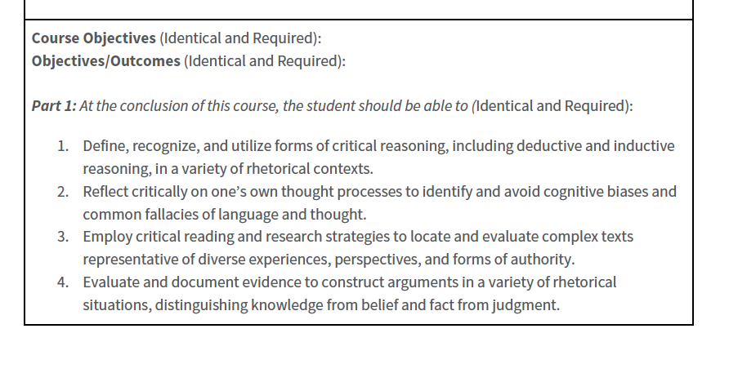
      * For now, I will be reviewing the common course numbering courses myself (designated with a C; POLSC100, ENGLC1001) since there is a huge rush on these. Once I (or our new Assessment Committee Co-Chair) start having the committee review these courses, it’s just a matter of making sure the authors are matching the template word-for-word.
      * We will still be reviewing all other courses as we always have. So business as usual for the committee.
4. We did a first read of the GE guiding notes. Remember this document applies to our local degrees only. Please take some time to review this week and come back with suggestions. The assessment committee is tasked with:
   1. Reviewing and approving wording on GELOs in all areas.
      * [Here is the most recent version](https://committees.bakersfieldcollege.edu/assessment/meetings/2024_09_20/supporting_docs/AC_BC_GE_Guiding_Notes_Updated_09_23.docx) with some verb changes by me and the curriculum co-chairs.
   2. Mapping of new and updated GELOs to ILOs.
      * I quickly learned in the meeting that this is not an easy discussion to have without some kind of draft or notes on it, so I will have some proposed mappings for us at the next meeting.
   3. Reviewing and approving [assessment data crosswalk](https://committees.bakersfieldcollege.edu/assessment/meetings/2024_09_20/supporting_docs/AC_GE_Crosswalk.xlsx).
      * With the reorganizing and naming of the GE Areas, there is some data that needs to be recategorized. Please review the proposed crosswalk and come to our next meeting with suggestions/comments/questions.

It would be great if we could get at least points a) and b) approved at the next meeting.

1. I trained everyone on [how to review learning outcomes in eLumen](https://committees.bakersfieldcollege.edu/assessment/meetings/2024_09_20/supporting_docs/AC_Reviewing_Learning_Outcomes_in_eLumen_09_20_24.pdf) using the [Learning Outcome Review Checklist](https://committees.bakersfieldcollege.edu/assessment/meetings/2024_09_20/supporting_docs/AC_Learning_Outcome_Review_Checklist_2024-25_Updated.pdf), which you all have already started using!
   1. I updated the review checklist to include things like number of SLOs (3-5) and expected SLO Performance (should be 70). Please be sure to follow these two documents closely when reviewing your courses.
      * I received a note from the curriculum team that a course was submitted without a comment about a missing intro phrase (Upon successful completion of the course, the student will be able to…..)
      * This also could be due to a reviewer not clicking the “add comment” button before submitting (See screenshot below) so please don’t forget that step!
      * 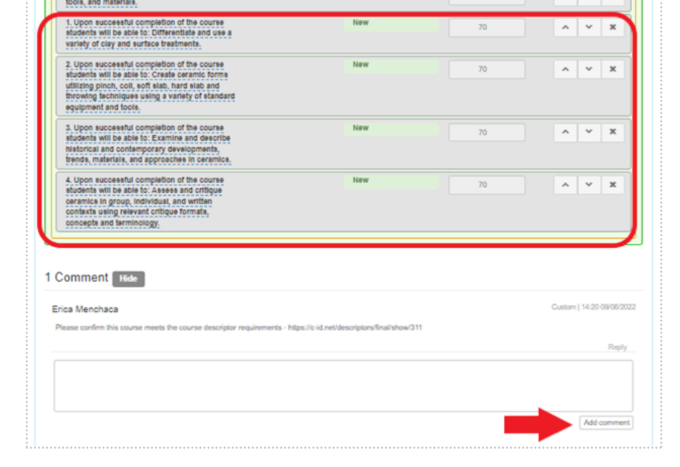
2. I gave out the first set of [Course Review Team Assignments](https://committees.bakersfieldcollege.edu/assessment/meetings/2024_09_20/supporting_docs/AC_Team_Assignments_09_20_24.docx). **This assignment is due to be completed by end of day this Friday 09/27.** I will send out an email reminder later this week to those who have not completed their assignments.
   1. If you do not yet see the Assessment Member role available to you in eLumen, please email me and I will fix that! But I believe everyone should have access now.
   2. Team K [@Debra Kennedy](mailto:dkennedy@bakersfieldcollege.edu) & [@Bryan Russell](mailto:bryan.russell@bakersfieldcollege.edu) – I was told there was a rush on SOCIB36 so I did that one for you already. 😊
   3. You can expect new team assignments Friday (or sometime before next Monday)
3. Ricardo Garza will be our proxy for AIQ Committee again. Thank you so much for volunteering!
4. I asked everyone to wear Red or a BC Shirt for the next meeting so that we can take our committee picture for the website. I will remind everyone again the week of.

I think that covers everything! Please let me know if you have any questions, and I’ll see everyone again (in red 😊) on October 4th!