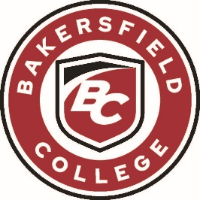
ADMINISTRATIVE COUNCIL MEETING
Monday, May 11, 2026
2:00 PM - 4:00 PM
Renegade Event Center

AGENDA
Facilitator: Stacy Pfluger, President

Item | Title | Presenter
1. | Welcome | Stacy Pfluger  Vice President, Instruction
2. | McKnight Organizational Study | Stacy Pfluger  Vice President, Instruction
3. | Strategic Plan 2025-30:  Year 1 Progress Report | Sooyeon Kim  Director, Institutional Effectiveness  Kim Nickell  Professor, Education
4. | 2025 Staff Climate Survey Results | Sooyeon Kim  Director, Institutional Effectiveness
5. | Commencement | PJ Delgaudio  Manager, College & Community Events
6. | 2027 Commencement | LaNina Andrews  Executive Director, Marketing and Public Relations

Next Admin Council Meeting: Fall 2026

Upcoming Important Dates and Events
Upcoming Home Sports

LEARNING • INTEGRITY • WELLNESS • DIVERSITY • COMMUNITY • SUSTAINABILITY

