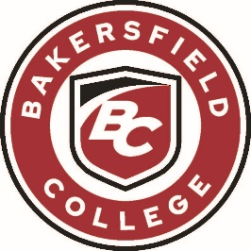
ADMINISTRATIVE COUNCIL MEETING
Monday, April 13, 2026
2:00 PM - 4:00 PM
Renegade Event Center

AGENDA
Facilitator: Jessica Wojtysiak, Vice President, Instruction

Item | Title | Presenter
1. | Welcome | Jessica Wojtysiak  Vice President, Instruction
2. | Program Review | Kristin Rabe  Assistant IT Director  Kimberly Nickell  Faculty
3. | Achieving the Dream Coaches | Cesar Jimenez  VP of Student Services
4. | College Discovery Academy | Nicole Alvarez  Executive Director, Early College Innovation & Access
5. | College Corps | Ben Perlado  Dean, Enrollment Services  Amerika Nino-Rodriguez  Program Director, SSJV Cal-SOAP
6. | Outstanding Balance Holds | Cesar Jimenez  VP of Student Services
7. | Claims for Travel Forms – Free & Virtual Meetings | Cesar Jimenez  VP of Student Services
8. | College Rebound | Nina Andrews  Executive Director, Communication & Marketing
9. | Basic Needs | Caitlin Davidson  Program Manager, Basic Needs
10. | Commencement | PJ Delgaudio  Manager, College & Community Events
11. | Finance & Administrative Services Updates | Denice McCauley  Associate Vice Chancellor, Accounting Services

Next Admin Council Meeting: May 11, 2026

Upcoming Important Dates and Events
Upcoming Home Sports

LEARNING • INTEGRITY • WELLNESS • DIVERSITY • COMMUNITY • SUSTAINABILITY

