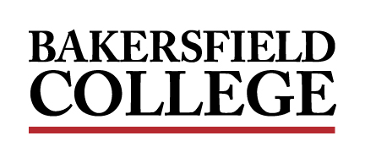
ADMINISTRATIVE COUNCIL MEETING
Monday, November 14, 2022
2:00 PM - 4:00 PM
Campus Center Ballroom East
A G E N D A

Facilitator: Jessica Wojtysiak, Associate Vice President of Instruction

Review of the Agenda
Item | Title | Presenter | Time
1. | Welcome and Opening Remarks | Wojtysiak | 05 min
2. | 6th Annual Undocumented Student Action Week | Garcia | 15 min
3. | Budget Office Updates/Reminders | Stallion | 05 min
4. | Student Life Updates | Ayala, Damania | 05 min
5. | Accreditation: ISER Prep | Wojtysiak | 45 minutes

