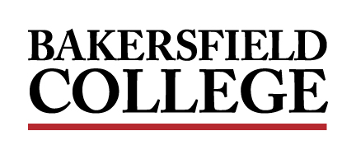
ADMINISTRATIVE COUNCIL MEETING
Monday, September 12, 2022
2:00 PM - 4:00 PM
Fireside Room
A G E N D A

Facilitator: Jessica Wojtysiak, Associate Vice President of Instruction

Review of the Agenda
Item | Title | Presenter | Type | Time
1. | Welcome and Opening Remarks | Wojtysiak | Information | 05 min
2. | Homecoming 2022, “Renegade Fever” | Ayala, Urias, Landon | Information | 10 min
3. | Renegade Promenade | Carter | Presentation | 05 min
4. | Enrollments | Hayward | Information | 10 min
5. | Starfish | Commiso | Presentation | 30 min
6. | Budget Office Updates | Boles, Rios | Information | 30 min
6. | HR Updates | Calderon | Information | 10 min

