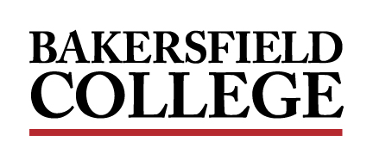
ADMINISTRATIVE COUNCIL MEETING
MONDAY, March 8, 2021
2:00pm - 4:00pm
Zoom
A G E N D A

Facilitator: Manny Mourtzanos

Review of the Agenda
1. | Welcome and Opening Remarks | Mourtzanos | Information | 05 min
2. | KCCD Classified and Management Salary Study | Mourtzanos  Calderon | Presentation | 10 min
3. | Office Technology Courses for Administrators and Classified Staff | Mourtzanos  Wojtysiak  Grijalva | Presentation | 15 min
4. | Human Resources Updates | Calderon | Presentation | 15 min
5. | Fall 2021 Flex Week | Rivers | Presentation | 10 min
6. | ConferZoom Recordings | Rivers | Presentation | 05 min
7. | Non-Credit Courses for Student Workers | Cordova  Baltazar  Grijalva | Presentation | 15 min
8. | Out of School Youth Programs | Baltazar  Lopez | Presentation | 10 min
9. | EODAC Equity Forum Announcement | Guzman  McCrow | Presentation | 10 min
Dates to Note:
- 03/08, 12-1pm Renegade Fitness - Zoom
- 03/10, 6pm Bakersfield College Phlebotomy Information Session - Zoom
- 03/11, 4-5pm Humanizing Your Course - Zoom
- 03/18, 11:30-1:30pm Design Tools: Basic - Zoom
- 03/19, 8-5pm CPR, AED & First Aid Certification Courses – Performing Arts Room 101
- 03/22, 4-5pm PlayPosit Basics Zoom
- 03/23, 3:30-5:30 Teaching Effectively with ConferZoom - Zoom
- 03/26, Last Day to Withdraw and Receive a “W”
- 03/31, Early Registration for Summer/Fall 2021
- 03/29-04/03, Spring Break
- 04/14, Open Registration for Summer/Fall 2021

BC Events Calendar
Renegade Athletics Schedule
Next Regular Meeting: April 12, 2021

