Question 1:

Academic Technology | 3.38
Professional Development | 3.03
Human Resources on BC Campus | 2.87
Event Scheduling and Room Reservations | 3.11
Facilities / Construction Office (major capital projects) | 3.06
Maintenance and Operations | 3.10
Mail Service | 3.46
Media Services | 3.51
Shipping and Receiving | 3.48

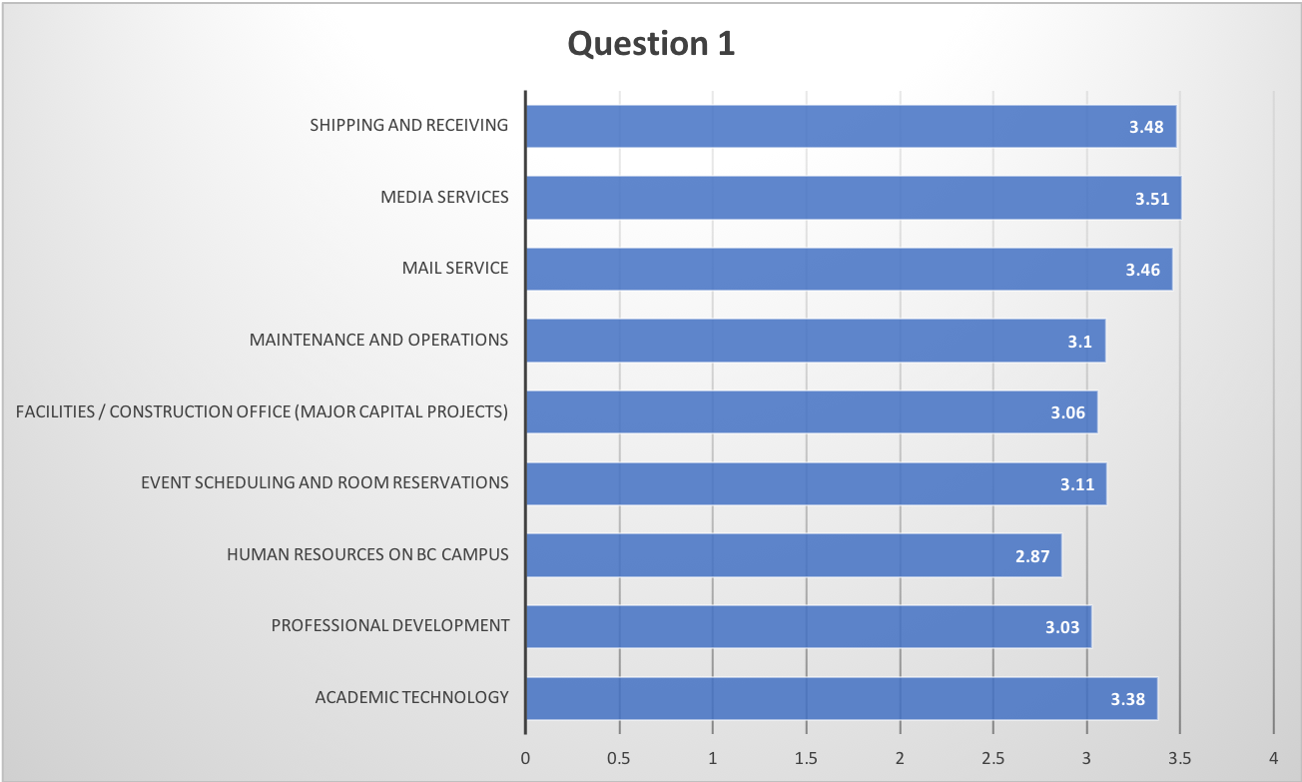
Question 2

Assessment Center | 3.40
Child Development Center | 3.57
Financial Aid | 3.36
Outreach and School Relations | 3.61

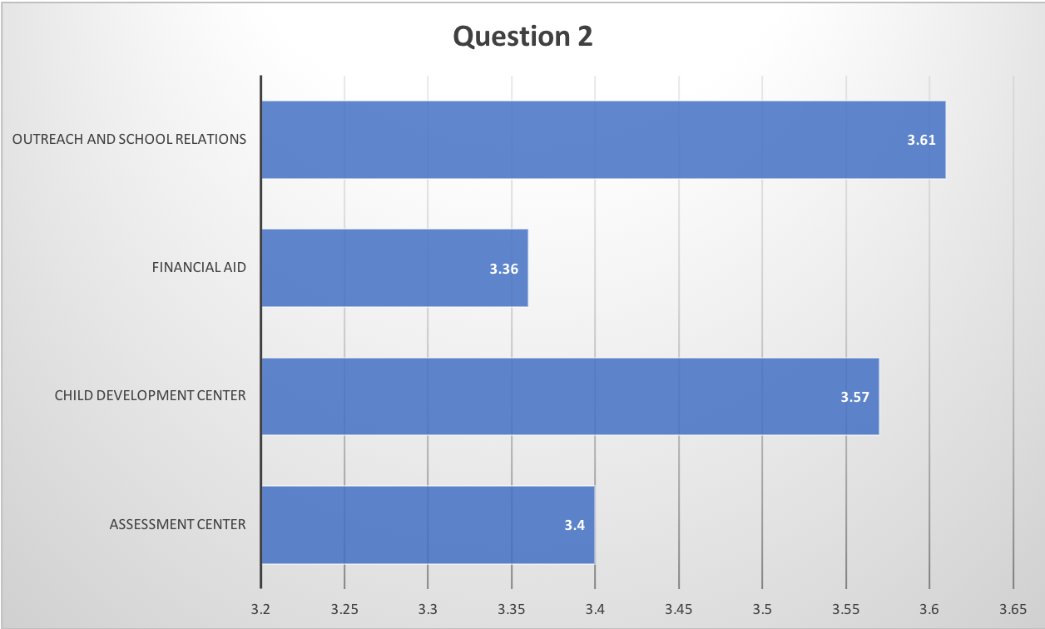
Question 3

Admissions and Records | 3.42
Bookstore | 3.13
Business Services Office on BC Campus | 3.30
Food Services | 3.48
Health and Wellness Center | 3.40
Library | 3.72
Public Safety | 3.53
Technology Support (Wifi, Labs, Network, Desktop Computing) | 3.44

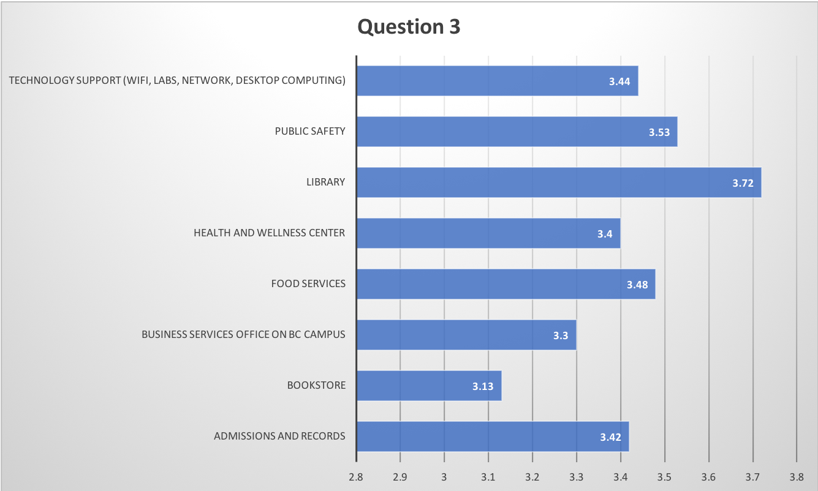

Question 4

Budget and Finance Office (Under VP of Finance and Admin Svc.) | 3.05
BC Foundation | 3.42
Marketing and Public Relations | 3.26
The President's Office and Support Staff | 3.43
Vice President of Instruction | 3.43
Vice President of Student Affairs | 3.27
Dean of Instruction: Thorson | 3.43
Dean of Instruction: Mourtzanos | 3.47
Dean of Instruction: Rice | 3.63
Dean of Instruction: Waller | 3.70
Dean of Instruction: McCrow | 3.38
Dean of Instruction: Commiso | 3.23
Dean of Instruction: Rozell | 3.63
Dean of Instruction: Rodriguez | 3.36
Dean of Instruction: Dixon | 3.49
Dean of Academic Technology: Moseley | 3.41
Dean of Institutional Effectiveness: Hayward | 3.46
Director of Rural Initiatives: Guzman | 3.53
Director of Athletics: Taylor | 3.53

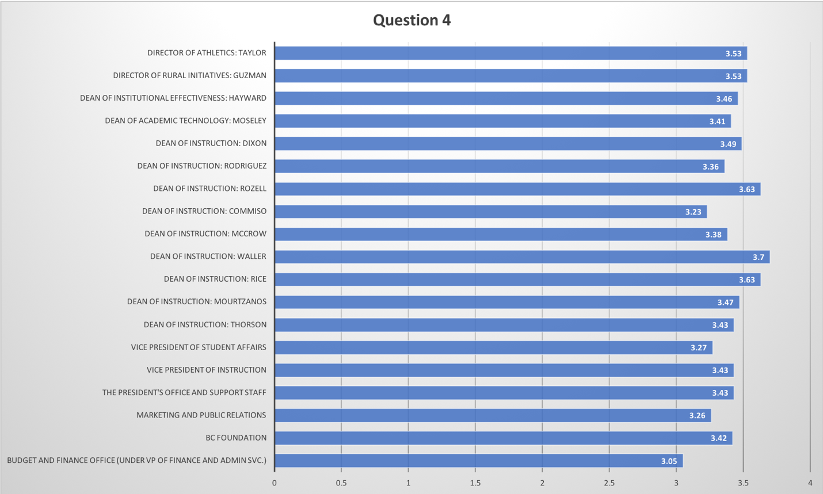
Question 5

Yes | 78.37%
No | 21.63%

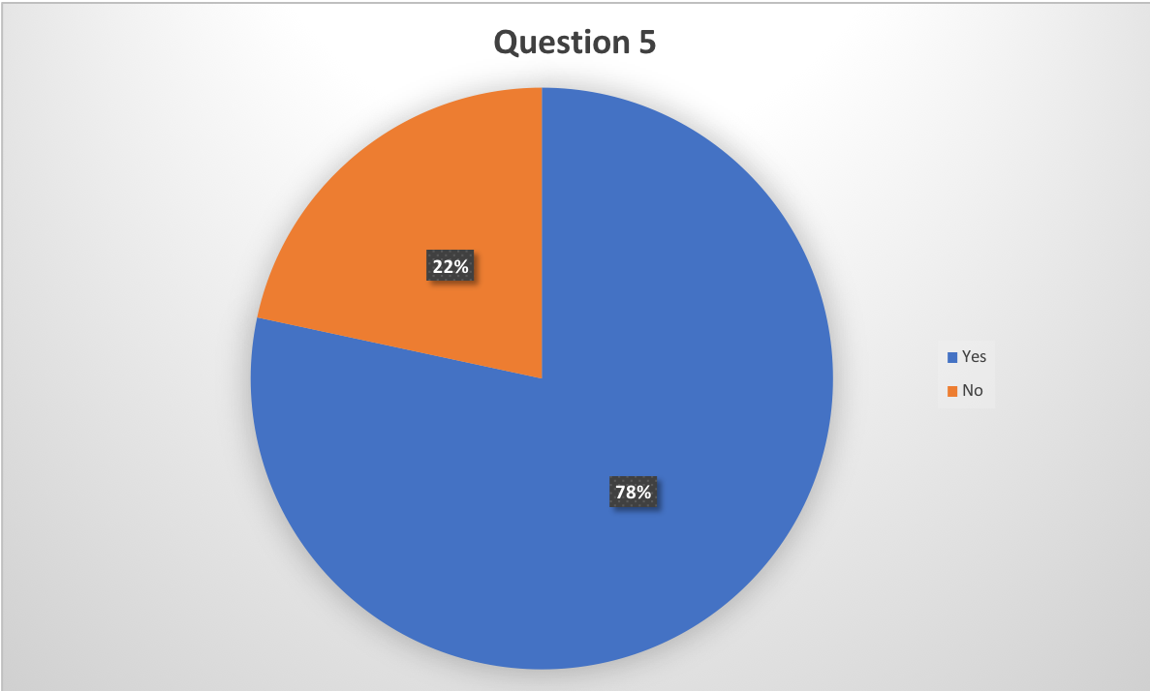

Question 6

Strongly Agree | 25.91%
Somewhat Agree | 44.04%
Somewhat Disagree | 16.06%
Strongly Disagree | 13.99%

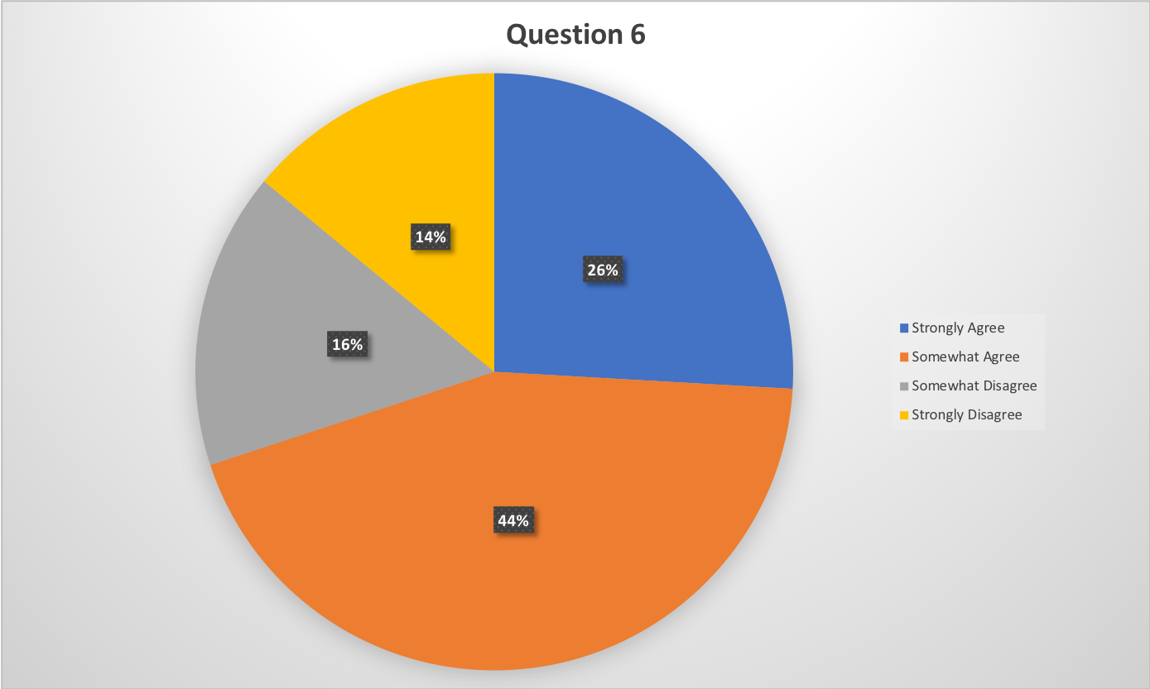

Question 7

Tenured or Tenure-track Faculty | 45.67%
Full Time Temporary Faculty | 1.44%
Adjunct Faculty | 14.90%
Classified Staff | 26.92%
Administration | 11.06%
Student | 0.00%

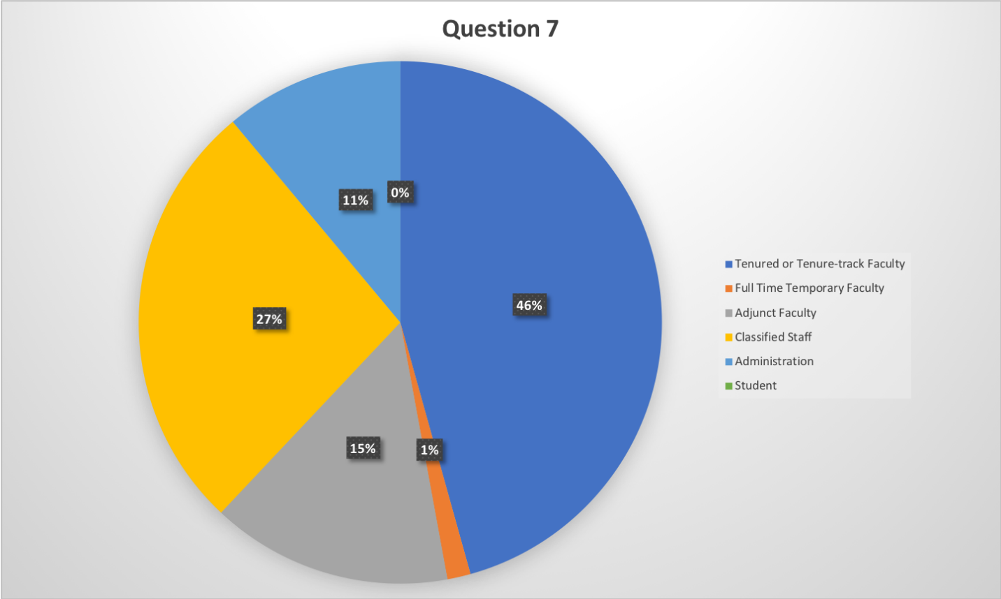
Question 8

More than 20 years | 18.01%
16-20 years | 9.00%
11-15 years | 11.85%
6-10 years | 10.90%
2-5 years | 26.07%
Less than 2 years | 24.17%

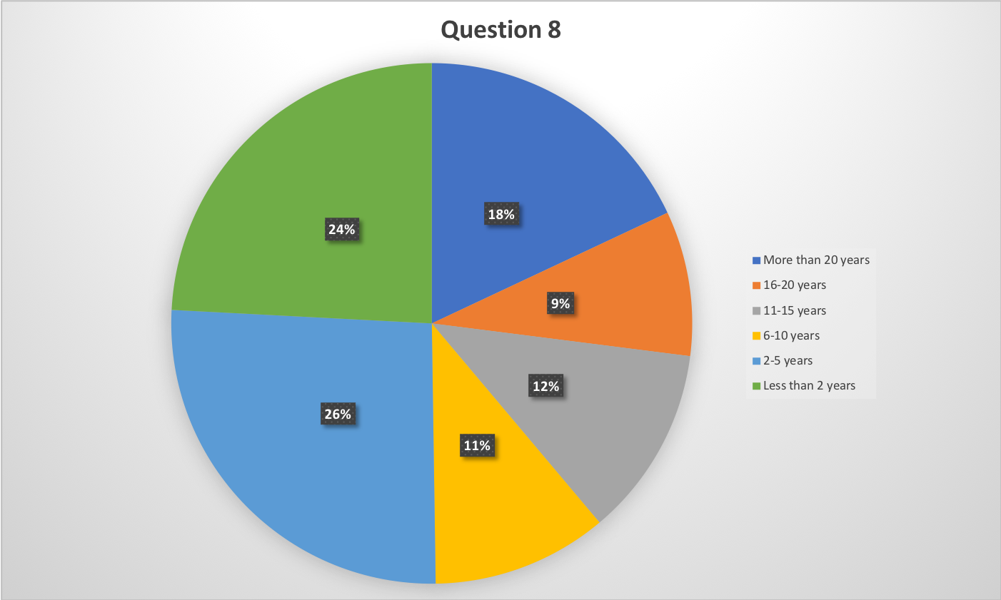
Question 9

Yes | 56.52%
No | 43.48%

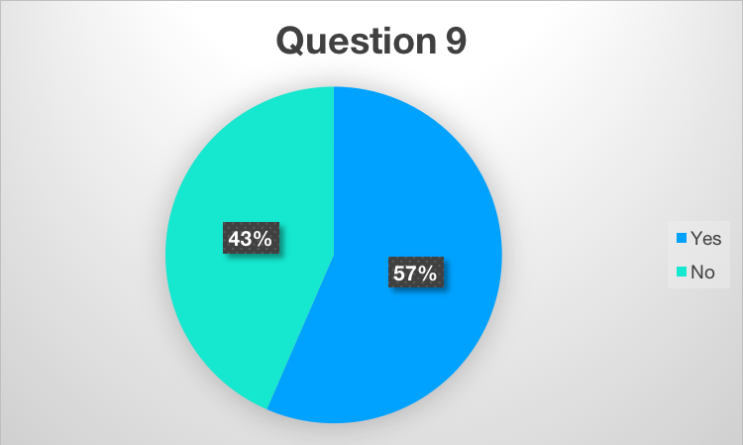

Question 10

Academic Senate | 13
Academic Senate Executive Board | 6
Accreditation & Institutional Quality Committee (AIQ) | 9
Administrative Council | 16
Assessment Committee | 9
Budget Committee | 7
College Council | 16
Curriculum Committee | 9
Data Coaches | 19
Educational Administrators Council | 5
Enrollment Management Committee | 2
EODAC | 8
Equivalency Committee | 3
Facilities Committee | 8
Faculty Chairs/Directors Council (FCDC) | 14
ISIT | 15
President's Cabinet | 14
Professional Development Committee | 3
Program Review Committee | 5
Safety Advisory Committee | 5
Student Affairs Leadership Team (SALT) | 5
SGA | 0
SGA Executive Board | 0
Other (please specify) | 31

Various committees in my department.
Scholarship Committee
Guided Pathways
Guided Pathways
English Colloquium
I feel this informaiton would be identifying.
CCA
Pathways
one of the above but did not want to be identified
Public Safety Committee, CTE Comittee, Pathways Committee, EMS Committee
African American Initiatives
Club advisor
pathways
Union
Delano Campus committees and activities
Foster and Homeless Advisory
I serve in several of those but I don't want to identify myself so I'll just mark "other"
Programs Pathway
None
Guided Pathways
Pathways
?
Student Conduct Hearing Panel
CTEC
CTE
STEM Coaching team, Scholarship committee
BC Campus Health Advisory
Levan program committee, steering committee
Strategic Directions, Accessibility Task Force
Pathways, Advisor for club on campus
Accessibility Task Force
Question 11

Panorama campus | 193
Delano | 7
Other (please specify) | 6

