**Institutional Strategy Map**

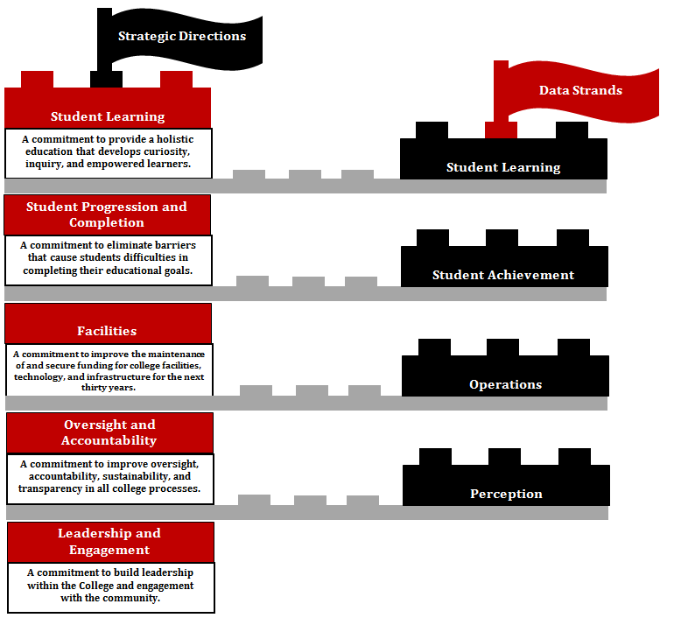

**Road Map to Institutional Effectiveness and Student Success**

The following pages include the initiatives developed for each of the 2015-2018 Strategic Directions. The intent is to complete the initiatives over the course of the three-year cycle. Each year the College will evaluate the progress it has made on each initiative.

Fall Committee Reports due in early November will focus on the status of the initiatives aligned with committee work. Using the icons below, the committees will report on their progress. Green means an initiative has been completed, green and yellow together represent work perpetually in progress, yellow indicates the work is in progress, and red shows that work has not yet begun. Initiatives with yellow or red icons will need to include action plans for completion. Committee Reports will be directed to the Accreditation and Institutional Quality Committee (AIQ) for review. Following its charge, AIQ will “review and monitor evaluation activities to ensure they result in integrated, meaningful, and sustained college improvement.” AIQ will analyze the Committee Reports, create a summary, and present the information to College Council in early December.

At the end of each academic year, committees will follow the same process, with AIQ presenting the analysis to the annual College Leadership Year-End Review & Planning Meeting.



Green means an initiative has been completed.



Green and yellow together represent work perpetually in progress.



Yellow indicates the work is in progress.



Red shows that work has not yet begun.

Initiatives with yellow or red icons will need to include action plans for completion.

|  |  |  |  |  |
| --- | --- | --- | --- | --- |
| **Direction #1 Student Learning**  *A commitment to provide a holistic education that develops curiosity inquiry, and empowered learners.* | | | | |
|  | **Initiatives** | **How will you evaluate and document the initiative’s success?** | **What committee or position would be responsible?**  **(The person closing the loop and reporting out)** | **Scoring** |
| **Academic Evaluation** | | | | |
|  | Identify and review internal and external standards and requirements for each of the four data strands for the Renegade Scorecard: Student Learning; Student Achievement; Perception; Operational. | Standards are posted on Renegade.  Scorecard web page.  *See Scorecard Data Strands.* | Accreditation & Institutional Quality Committee (AIQ) |  |

|  |  |  |  |  |
| --- | --- | --- | --- | --- |
| **Direction #4 Oversight and Accountability**  *A commitment to improve oversight, accountability, sustainability, and transparency in all college processes.* | | | | |
|  | **Initiatives** | **How will you evaluate and document the initiative’s success?** | **What committee or position would be responsible?**  **(The person closing the loop and reporting out)** | **Scoring** |
| **Accountability** | | | | |
| 11 | Use Strategic Directions to focus committee work plans and reports. | The synthesis and scoring are created and posted. | AIQ,  College Council |  |
| 12 | Renegade Scorecard: i. Update annually to the latest version of the scorecard, ii. Identify internal and external standards. | Standards are posted on Renegade Scorecard web page. | AIQ |  |
| 13 | Ensure internal deadlines are met. Examples include Program and Curricular Reviews. | Internal deadlines are clearly publicized and met. Committees and other entities need procedures to deal with late work and report that deadlines have been met. | AIQ,  All committees |  |
| 15 | Measure end user satisfaction with college and district services annually. | Satisfaction surveys from end users on campus surveys | AIQ |  |

**Implementation**

The College President and College Council are responsible for implementing the Bakersfield College Strategic Directions Plan. The following table illustrates other responsible committees, councils, and executive leadership.

|  |  |  |  |  |
| --- | --- | --- | --- | --- |
| **Student**  **Learning** | **Student Progression**  **and**  **Completion** | **Facilities** | **Oversight**  **and**  **Accountability** | **Engagement**  **and**  **Leadership** |

|  |  |  |  |  |
| --- | --- | --- | --- | --- |
| **Committees & Councils:**  Academic Senate  AIQ  Assessment  Curriculum  EODAC  Facilities  FCDC  Program Review | **Committees & Councils:**  Curriculum  Enrollment Management  FCDC  Students of Concern | **Committees & Councils:**  Facilities  ISIT  Sustainability | **Committees & Councils:**  Academic Senate  All committees  AIQ  Assessment  Budget  Program Review | **Committees & Councils:**  EODAC  FCDC  Professional Development |
| Dean of Academic Technology  Deans of Instruction  Dean of Pre-collegiate & Student Success  Dean of Student Success  Marketing and Public Information Director  MESA Director  Outreach Director  Student Life Director  STEM Program Manager  Supplemental  Instruction Coordinator  CTE Advisors  SGA | Dean of Academic Technology Deans of Instruction over CTE areas  Dean of Pre-collegiate &  Student Success  Dean of Student Success  Enrollment Services Director  Director of Student Equity & Inclusion  Financial Aid Director  Outreach Director  Transfer Center  Counseling Department | IT Director  M&O Manager  Public Safety  Student Affairs Leadership Team  Director, Health & Wellness Center  BC Foundation  Community Relations and Event Scheduling | President’s Cabinet  President’s Office  Director of Student Equity & Inclusion  Institutional Research | Deans of Instruction over CTE areas  Dean of Instruction responsible for adjunct faculty orientations  Dean of Instruction, Rural Initiatives  Director of Student Equity & Inclusion  Director, Health & Wellness Center  IT Director  Marketing & Public Information Director  Outreach Director  Student Life Director  Student Affairs Leadership Team  CTE Program Manager  BC Foundation  SGA |
|  |
|  |
|  |  |  |  |  |
| **Executive Leadership** | **Executive Leadership** | **Executive Leadership** | **Executive Leadership** | **Executive Leadership** |
| VP, Academic Affairs, primary | VP, Academic Affairs, primary | VP, Academic Affairs | VP, Academic Affairs | VP, Academic Affairs |
| VP, Admin Services | VP, Admin Services | VP, Admin Services, primary | VP, Admin Services | VP, Admin Services |
| VP, Student Affairs | VP, Student Affairs | VP, Student Affairs | VP, Student Affairs | VP, Student Affairs |

***Collegewide and Governance Committees:*** *Accreditation &Institutional Quality (AIQ), Assessment, Budget, College Council, Curriculum, Enrollment Management, Equal Opportunity* & *Diversity Advisory EODAC), Facilities, Faculty Chairs* & *Directors Council (FCDC), Information Systems and Instructional Technology (ISIT), Professional Development (PDC), Program Review (PRC), and Safety.*